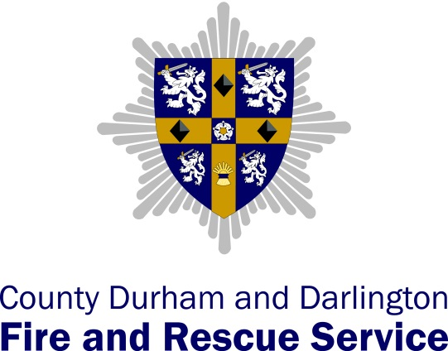
Annual Equality Data Report
January 2015
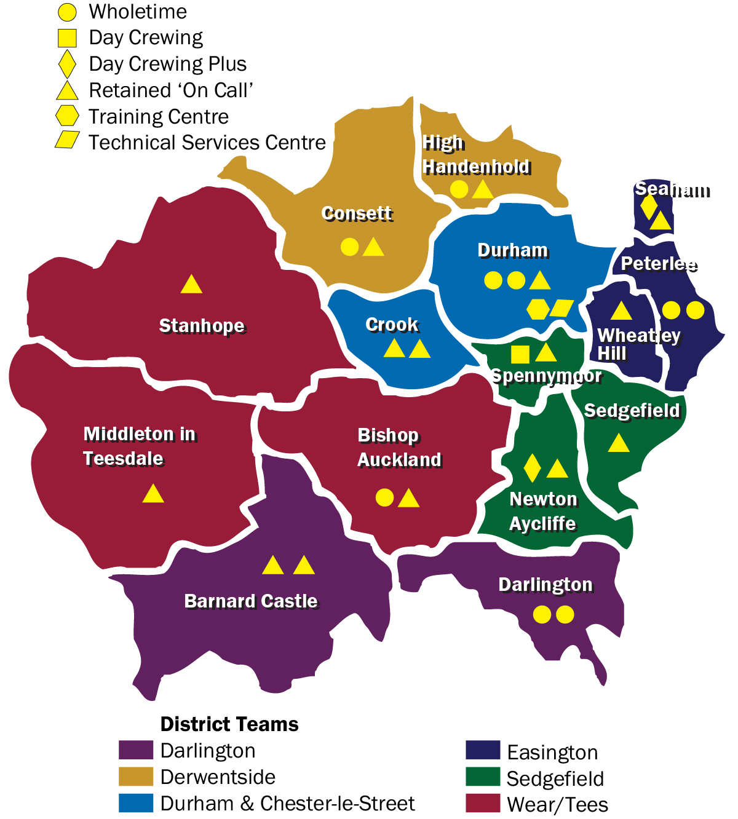

Introduction

The Public Sector Equality Duty which came into force on 1st April 2011 requires public authorities like ourselves, to publish information to demonstrate we comply with the general equality duty. This requires authorities to have due regard to the need to:

- Eliminate discrimination, harassment and victimisation and other conduct prohibited by the Equality Act;
- Advance equality of opportunity between people who have a protected characteristic and those who do not; and
- Foster good relations between people who have a protected characteristic and those who do not.

County Durham and Darlington Fire and Rescue Service (CDDFRS) is required to produce an annual report to demonstrate our compliance with the general equality duty. This report must include information about our employees and the people who we provide a service to in County Durham and Darlington.

This report will be accessible to the public and will enable customers, staff and our regulators to assess our equality performance. Findings also enable us to identify equality priorities and development areas which inform our equality objectives.

We also publish equality objectives, every four years commencing from 6th April 2012 to show how we meet the general equality duty.

Data and information has been collated for the period 1st April 2013 to 31st March 2014 and some comparisons have been made to the previous year. This report details both Service and Employee data to show how as a Fire and Rescue Service we take protected characteristics into account in all we do, such as decision making, employment and the services we provide to the public.
The protected characteristics covered by the Equality Act are:

- Age;
- Disability;
- Gender;
- Gender reassignment;
- Marriage and civil partnership;
- Pregnancy and maternity;
- Race;
- Religion and belief;
- Sexual orientation.

Employee Data
Current Employees
Number of employees in post 2012 – 2014 (31st March 2014)
Year | Wholetime | RDS | Control | Non Uniform | Total
2012 | 365 | 174 | 28 | 77 | 644
2013 | 350 | 181 | 30 | 77 | 638
2014 | 341 | 185 | 29 | 68 | 623
Change 13/14 | -9 | +4 | -1 | -9 | -15
Percentage change 13/14 | -9% | +2% | -1% | -12% | -2%

Over the last three years the number of staff employed by CDDFRS has reduced. Since 2012, this has been mainly due to the necessary organisational restructure and the review and subsequent change to some of our working practices. Employees have been redeployed where possible and a recruitment freeze implemented which has prevented the need for any compulsory redundancies.
In 2014 although wholetime numbers have decreased slightly due to retirements and the ongoing recruitment freeze, the Retained Duty System (RDS) numbers have increased. This is due to more flexibility in contracted hours, enabling us to take on more staff with lower percentage cover.

Staffing strength (FTE) by role (31st March 2014)
Role | Wholetime | RDS | Control | Non Uniform | Total
Principal Officers | 2 | 0 | 0 | 1 | 3
Area Manager/Grade 15 | 4 | 0 | 0 | 1 | 5
Group Manager/ Grade 14 | 7 | 0 | 1 | 0 | 8
Station Manager/ Grade 10-13 | 26 | 0 | 1 | 9 | 36
Watch Manager/ Grade 8-9 | 56 | 15 | 5 | 16 | 92
Crew Manager/ Grade 7 | 51 | 37 | 4 | 11 | 103
Firefighter/  Grade 6 and below | 196 | 133 | 17 | 30 | 376
Total | 342 | 185 | 28 | 68 | 623

Age
Age of employees (31st March 2014)
 | 17-24 | 25-35 | 36-45 | 46-55 | 56-65
Wholetime | 1 | 67 | 167 | 105 | 3
RDS | 17 | 63 | 56 | 39 | 10
Control | 1 | 8 | 8 | 9 | 1
Non Uniform | 2 | 13 | 19 | 21 | 13
Total | 21 | 151 | 250 | 174 | 27

What does this tell us?
The majority of staff (40%) are within the 36-45 age range which is to be expected. We have a very small proportion of staff (3%) in the 17-24 age range, the majority of which are RDS staff. Due to the nature of the role of fire-fighter and legislative requirements associated with recruitment we have no employees under the age of 18. We have reviewed our work experience policy which will result in the Service engaging with more young people which may improve these figures. Our operational crews and community safety staff visit local educational establishments when the opportunity arises and three of our fire stations run Young Firefighters Schemes.
We also have a small proportion (4%) of staff over the age of 56. Although the Service encourages workers to remain after retirement age, it tends to be a small minority of employees who do remain in the Service after they are able to retire. It is anticipated that the impending changes to the fire service pension scheme will impact this statistic moving forward.
Disability

What does this tell us?
3.9% of our workforce have declared themselves to have a disability. This is higher than the national average for the Fire and Rescue Service in England, where less than 1.5% of staff declared a disability. (Communities and Local Government Fire and Rescue Service Equality and Diversity Report 2009). This may be due to our commitment to improving support mechanisms and accessibility for our disabled employees. We have held the Two Ticks Disability Symbol for over a decade which also demonstrates our commitment to disability.
Over the previous two years we have recognised that mental health issues are on the increase. Our Health and Fitness Advisor and Human Resources Team have been proactive in raising the awareness of mental health issues, providing mental health first aider training for a group of staff who are able to identify the signs of mental health and how to signpost employees to the correct treatment and support. We also provide the Employee Assistance Programme which is a free confidential helpline for all employees, providing advice and guidance on a wide range of issues.
All new buildings across our estate are fully accessible enabling us to employ disabled members of staff and improve our engagement with the disabled community. We support our disabled employees by making reasonable adjustments where possible. For example, we have provided specialised keyboards and wrist rests, specialist chairs and desk adjustments where necessary.
We also operate modified duties and phased return to work to support employees when returning to work following a long term period of ill health, injury, welfare grounds or if deemed necessary by the service.
Gender
Gender of employees 2012 – 2014 (31st March 2014)
 | 2012 |  | 2013 |  | 2014
 | Men | Women | Men | Women | Men | Women
Wholetime | 351 | 14 | 337 | 13 | 328 | 13
Retained | 168 | 6 | 177 | 4 | 178 | 7
Control | 2 | 26 | 3 | 27 | 3 | 26
Non Uniform | 44 | 33 | 43 | 34 | 34 | 34
Total | 565 | 79 | 560 | 78 | 543 | 80

What does this tell us?
Uniformed employees are predominantly white males with only 3.5% of uniformed staff which are women. This is due to females finding the selection tests more difficult than males due to the strength aspect as well males in general being more interested in a career as a fire fighter than females.
The wholetime data includes employees who are not currently operational and work the day duty system. As mentioned earlier in the report the number of male wholetime employees has steadily reduced over the last three years due to the recruitment freeze and retirements.
The number of uniformed female employees has risen from 17 (of which 13 were operational firefighters) in 2013 up to 22 (of which 15 were operational firefighters) in 2014. This slight increase was due to more female applicants for RDS firefighter roles meeting the required entry standards than previous years. CDDFRS welcome female RDS firefighters and ongoing RDS recruitment should improve this figure in the coming years.
Gender Reassignment
We currently do not collect gender reassignment data from employees and would be unable to publish any data to ensure anonymity for our employees.
Marriage and civil partnership
We currently do not collate marriage and civil partnership data from employees. However the introduction of a new back office system will enable us to gather this information from employees so that future data can be reported on.
Pregnancy and Maternity
Pregnancy and maternity in employees 2012-2014 (31st March 2014)

 | 2012 | 2013 | 2014
Number expected to return | 3 | 4 | 1
Total number returned | 3 | 4 | 1

What does this tell us?
Women who have taken maternity leave in the last three years have all returned to their original roles. This is a positive statistic which can be attributed to the work we have done on our work life balance policies. CDDFRS are committed to offering flexible employment practices which recognise that staff want to find a sensible balance between their home and work life. We offer flexible working, job share, career breaks, child care vouchers as well as various types of leave to employees to be as family friendly as possible.
We have reviewed our maternity policy and maternity benefits to improve our current terms and conditions and incorporate the Shared Parental Leave Regulations in 2015. This will enable us to gain credibility through women and family organisations, increase recruitment and retention of our workforce and improve staff morale and engagement. Employees will be able to share parental leave with their partner if they are also eligible, offering greater flexibility in meeting the child care issues of our employees.

Race
Ethnicity of employees 2012 – 2014 (31st March 2014)
Ethnicity | 2012 | 2013 | 2014
White British/Irish | 623 | 618 | 606
White Other | 4 | 5 | 5
Mixed | 3 | 3 | 2
Asian/Asian British | 2 | 2 | 2
Black/Black British | 6 | 6 | 7
Chinese | 0 | 0 | 0
Other Ethnic Minority | 0 | 0 | 0
Not Stated | 6 | 4 | 1
Total percentage ethnic minority employees | 2.3% | 2.5% | 2.6%

What does this tell us?
The number of ethnic minority employees has remained fairly constant over the last three years. However, the percentage of ethnic minority staff across the overall workforce has slightly increased due to a drop in staff numbers who were all white British. This percentage of 2.6% is lower than the national average 3.2% for the Fire and Rescue Service in England (Fire and Rescue Service Equality and Diversity Strategy 2008-2018). However 2011 census data (Office for National Statistics Census 2011) shows 98.1% of County Durham population are white and 95.9% of Darlington are white. There is very little diversity within our communities which would make it difficult for us as a service to ensure our percentage of staff compared to the national average.
Religion and belief
We currently do not collate religion and belief data from employees. However the introduction of a new back office system will enable us to gather this information from employees so that future data can be reported on.
Sexual Orientation
We currently do not collate sexual orientation data from employees. However the introduction of a new back office system will enable us to gather this information from employees so that future data can be reported on. The service is now included on the Stonewall Equality index and has instigated numerous initiatives to ensure we provide an equal environment for all staff that is free from discrimination based on sexual orientation. The implementation of our Lesbian, Gay, Bisexual and Transgender (LGBT) network will provide support for LGBT staff and increase the understanding LGBT issues.

Recruitment
Due to the change in the Service’s procedure for RDS recruitment and the current wholetime recruitment freeze, no data is available for this subject. However, the Service is considering a data collection procedure which will provide detailed statistics to cover this area.
Leavers
Number of leavers (1st April 2013 - 31st March 2014)
Reason for leaving | Wholetime | RDS | Control | Non Uniform
Dismissal on disciplinary grounds | 1 | 2 | 0 | 0
Medical discharge | 0 | 1 | 0 | 0
Resignation due to harassment or discrimination | 0 | 0 | 0 | 0
Poor performance/efficiency | 0 | 0 | 0 | 0
Compulsory redundancy | 0 | 0 | 0 | 0
Voluntary redundancy | 0 | 0 | 0 | 5
Early retirement | 0 | 0 | 0 | 2
Normal retirement | 5 | 0 | 0 | 0
Re employment with another FRS | 0 | 0 | 0 | 0
Resignation to undertake other employment | 1 | 1 | 0 | 7
Deceased | 0 | 0 | 0 | 0
Other | 0 | 16 | 1 | 3
Total | 7 | 20 | 1 | 17

Age, Gender and Race
Age, gender and ethnicity of leavers (31st March 2014)
Age |  | Gender |  | Ethnicity |  | Disability
17-24 | 3 | Male | 39 | White British | 45 | Yes | 0
25-35 | 11 | Female | 6 | Any other | 0 | No | 45
36-45 | 9
46-55 | 13
56-65 | 9

What does this tell us?
During 2013-14, 45 employees left CDDFRS. Wholetime employees left mainly due to retirements, as many employees recruited in the 70s are now reaching retirement age. There were however, no ill health retirements.
RDS leavers were mainly due to employees finding alternative employment. This is commonly the case with the RDS as it is a part-time role and in the majority of cases their primary employment takes priority. It is for this reason that the RDS have a relatively high turnover and require regular recruitment drives.
Of the leavers, all were white British; none were disabled and most were male. Again this correlates with the general profile of a firefighter in the County Durham and Darlington area. The female leavers were all non-uniform or control staff who had found alternative employment. The age range of leavers varies but as would be expected the majority of leavers were in the 46-55 age bracket which is the retirement age for firefighters.
Service User Data
Home Fire Safety Visits
Age
Age of people receiving home fire safety visits 2013/2014
(31st March 2014)
Age | Number of people | Percentage
Under 65 | 10,727 | 67.2%
Over 65 | 5,228 | 32.8%
Total | 15,955 | 100%

What does this tell us?

The percentage of people over 65 (elderly) receiving home fire safety visits is 32.8% which is a slight increase on last year’s figure of 30%. This is as a result of the continued efforts by the Community Safety Team to engage directly or indirectly with this group. There was a particular focus on working with local housing associations as they provide the Service with a crucial link to older, vulnerable persons. Community Safety has also continued to provide training to county councils and other agencies that have links with this age group. It remains an important area of work for the Service and the associated performance indicator is scrutinised on a monthly basis by district teams and regularly by senior management.

Disability

Disability of people receiving home fire safety visits 2013/2014
(31st March 2014)
 | Number of people | Percentage
Disability | 359 | 2.3%
No disability | 15,596 | 97.7%
Total | 15,955 | 100%

What does this tell us?

The percentage of people receiving home fire safety visits that have declared themselves to have a disability is only 2.3% which is an increase on last year’s figure of 1.86%. Census 2011 data for the County Durham area (Office for National Statistics Census 2011) shows 12% of people, considered themselves to have a long term health problem or disability which affected their day to day activity a lot and a further 11% which affected their day to day activity a little. There may be several reasons why our percentage is not closer to the 12% Census figure. It is likely that many of those who declare themselves as having a disability will also be elderly and reside in a care home or similar type of accommodation where the Service do not carry out home fire safety checks. It may also be the case that many people do not declare themselves as having a disability when our staff visit their home. Our focus remains to target those most vulnerable to harm from fire and having a disability will not immediately put an individual at risk from fire.

Gender

Gender of people receiving home fire safety visits 2013/2014
(31st March 2014)
Gender | Number of people | Percentage
Female | 8,601 | 54%
Male | 6,171 | 38.6%
Not stated | 1,183 | 7.4%
Total | 15,955 | 100%

What does this tell us?

7.4% did not state gender, which is a huge improvement from the previous year where 26.5% of people didn’t state gender. The Community Safety administration team has carried out numerous visits to update operational crews who were identified as performing poorly on the recording of this statistic. It is also likely that the figure is skewed towards females due to the number of referrals coming from families with young children where the female is statistically more likely to be at home when the visit is carried out.

Race
Ethnicity of people receiving home fire safety visits 2013/2014
(31st March 2014)
Ethnicity | Number of people | Percentage
White – British | 14,997 | 94%
White – Irish | 180 | 1.1%
White – Other White | 60 | 0.38%
Mixed – White & Black Caribbean | 4 | 0.03%
Mixed – White & Black African | 3 | 0.02%
Mixed – White & Asian | 3 | 0.02%
Mixed – Other mixed | 6 | 0.04%
Asian or Asian British – Indian | 33 | 0.21%
Asian or Asian British – Pakistani | 7 | 0.04%
Asian or Asian British – Bangladeshi | 2 | 0.01%
Asian or Asian British – Other Asian | 15 | 0.09%
Black or Black British - Caribbean | 6 | 0.04%
Black or Black British - African | 7 | 0.04%
Black or Black British – Other Black | 2 | 0.01%
Chinese or Other Ethnic Group – Chinese | 5 | 0.03%
Chinese or Other Ethnic Group – Other | 1 | 0.01%
Not stated | 624 | 3.9%
Total | 15,955 | 100%

What does this tell us?
In 13/14, 94% of the people who received a home fire safety visit were White British and 2.1% were from ethnic communities. As discussed earlier in the report, the percentage of ethnic minorities receiving home fire safety visits correlates with the percentage of ethnic minority people living in the County Durham area (Office for National Statistics Census 2011). There is an improvement from last year for ‘not stated’, falling from 9.12% to 3.9%. This can be largely explained by work done by the Community Safety team and operational crews using standardised forms to record the data when completing home fire safety visits, as well as encouraging operational crews to ask the questions and educating members of the public on the reasons for asking the questions. Community Safety has also made efforts to explain to operational crews the importance of accurate recording to help address risks and this work seems to be having an effect.
Operational Data
CDDFRS collect data from members of the public (service users) involved in incidents including primary fires and special services such as road traffic collisions, other rescues and secondary fires.
Age
Age of people involved in incidents 2013/2014 (31st March 2014)
Age | Number of people | Percentage
0-4 | 55 | 7.48%
5-9 | 15 | 2.04%
10-14 | 21 | 2.86%
15-19 | 48 | 6.53%
20-24 | 39 | 5.31%
25-29 | 33 | 4.49%
30-34 | 35 | 4.76%
35-39 | 31 | 4.22%
40-44 | 28 | 3.81%
45-49 | 29 | 3.95%
50-54 | 20 | 2.72%
55-59 | 26 | 3.54%
60-64 | 25 | 3.40%
65-69 | 21 | 2.86%
70-74 | 20 | 2.72%
75-79 | 15 | 2.04%
80-84 | 19 | 2.59%
85-89 | 10 | 1.36%
90-94 | 9 | 1.22%
95-99 | 1 | 0.14%
Not stated | 235 | 31.97%
Total | 735 | 100.00%

What does this tell us?
The largest proportions of people involved in incidents were infants age 0-4. This is due to the heightened level of precautionary checks that children of this age group require. Families with young children are a higher risk group which are targeted via community safety education and home fire safety visits. The Service carries out wide ranging engagement activities to reach all sections of our community. This is with the aim of mitigating and minimising occurrences of fire and other accidents in the home. These engagement activities use a multi-agency approach, working with partners such as health, social housing providers and other community groups, to ensure that the broadest and most representative range of audience is reached.
The Service supports a range of national safety weeks and carries out high profile prevention campaigns through the Operations and Community Safety Sections. This includes activities around kitchen safety week and religious festivals.
The second highest proportion is young people within the 15-19 and 20-24 age groups. Road traffic collisions can account for a heightened number of casualties in this area. Operational teams under the guidance of their District Management Team educate these age groups with RTC reduction information as part of focussed campaigns throughout the year e.g. Road Safety Week.
Gender
Gender of people involved in incidents 2013/2014 (31st March 2014)
Gender | Number of people | Percentage
Female | 308 | 41.90%
Male | 405 | 55.10%
Not known | 12 | 1.63%
Not specified | 10 | 1.36%
Total | 735 | 100%

What does this tell us?
The majority of people involved in incidents were male, this is an area of concern, with a significantly higher number of males involved in all incidents that the Service attends. This can be attributed to lone male occupants of properties being at higher risk to fire due to a number of factors such as drug or alcohol misuse and social exclusion. The proportion of male drivers involved in road traffic collisions is also significantly higher than females. The service engages in preventative activities to address issues of social exclusion and isolation amongst all sections of the community. Both of these groups are targeted as part of District and Service projects and plans.
Race
Ethnicity | Number of people | Percentage
Asian or Asian British – Other Asian | 2 | 0.27%
Black or Black British - African | 1 | 0.14%
Black or Black British - Caribbean | 1 | 0.14%
Chinese | 2 | 0.27%
Not known/stated | 196 | 26.67%
Other ethnic group | 2 | 0.27%
White - British | 521 | 70.88%
White - Irish | 3 | 0.41%
White – Other White | 7 | 0.95%
Total | 735 | 100%

What does this tell us?
70.88% of people involved in incidents were White British which is lower than the percentage of White British people living in the County Durham and Darlington area of 98.1% (Office for National Statistics Census 2011). This difference could be accounted for by the 26.67% percentage of people who didn’t state what ethnicity they were.
The remainder of people who were involved in incidents 2.5% is fairly proportionate to the 1.9% of ethnic minority people living in the County Durham and Darlington area. However it is important to note that main transport arteries such as the A1M and A19 run the length of the Service area. It is possible that the victims/ persons involved in RTC/Special Service incidents may be travelling through and not residents of the Service area.

