How do I make a comment, compliment or complaint to the Fire and Rescue Service?

Please ask us if you would like this document summarised in another language or format.

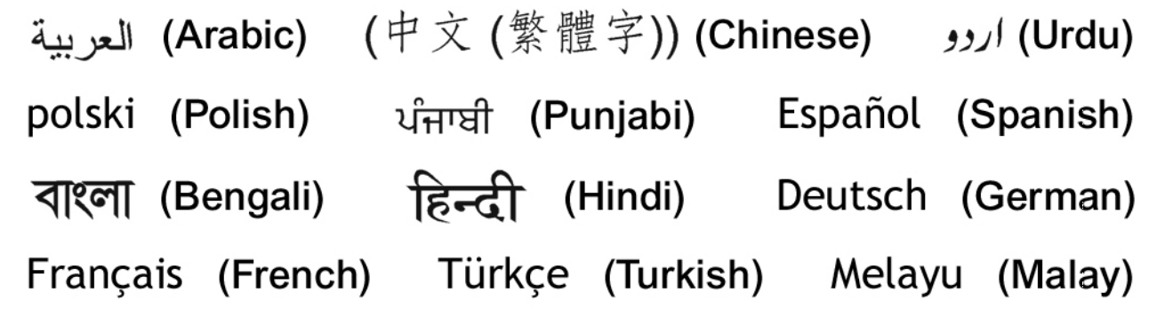

Introduction

County Durham and Darlington Fire and Rescue Service aims to provide the highest standards of fire, rescue and community safety services. As a customer, there may be times when you wish to comment on the Fire and Rescue Service. We encourage complaints, compliments and comments from all members of our community as we value your opinion and it can help us to continually improve our service.
This booklet has been produced to help you if you wish to make a comment, compliment or complaint about our service.
We promise that if you make comment, compliment or complaint you will:
- be listened to;
- receive a prompt and speedy response;
- be treated fairly and with courtesy and respect and
- be given confidentiality.
In addition, no matter what you have to say, we promise that it will not affect any current or future service you may receive from us.
Will my comment, compliment or complaint make a difference?
Yes.
When we receive thanks for the work that we do, it gives everyone a tremendous sense of satisfaction.
We take all comments and complaints seriously, as they form part of an ongoing review to maintain and improve our service.
We continually work towards our vision of:
Safest People, Safest Places

Comments & Compliments

If you have a suggestion about our Service or would like to compliment or thank us about something please complete our online form.
Verbally
If you would rather not complete the online form you can speak to the person (or their manager) who provided the Service you wish to comment about.
By telephone
You can speak to our Reception staff at HQ on 0345 305 8383
In writing
You can write to the Chief Fire Officer, Fire and Rescue Service Headquarters, Belmont Business Park, Durham, DH1 1TW

Please note that if you do not use our online form, whichever other method you use to submit your compliment or comment we will then record it using our online form, which we will complete on your behalf. We do not need to retain your personal details for this unless you would like a reply.

Complaints

How do I make a complaint?

We are committed to dealing with your complaint as quickly and effectively as possible and our complaints procedure will help us to ensure that this is the case. It gives you the opportunity to have your complaint handled in an informal or formal way, or both.
Informal complaints are those that raise issues that can be dealt with effectively and quickly by the department manager. They usually relate to a single department or a single issue and do not require a detailed investigation. We expect the majority of complaints to be pursued this way.
A formal complaint can be made in writing at any time and if you think your issue is too important to be handled in an informal way. It can also be made if you are not satisfied with the response you have received through our informal process.
Our staff are at hand to help you make your complaint in a way that is most suitable to you.

Stage 1 — Making an Informal Complaint

If you feel dissatisfied with any aspect of our Service, you can let us know by completing our online form, or you can speak to any member of staff. For informal matters we encourage you to speak directly and informally to the person with whom you have been in contact to see if the issue can be resolved.
You can use any of the methods described in our Comments and Compliments Section to make your complaint.
In all cases we will record the details of your complaint using our online form – you can complete this yourself or we can do this for you if you prefer. You can choose to remain anonymous and the complaint will be dealt with in the same way, with the exception that we will not be able to get back to you with the outcome.
If you are unsure who to contact about your informal complaint, you should get in touch with our Reception staff at:
Fire and Rescue Service Headquarters,
Belmont Business Park,
Durham
DH1 1TW

Telephone 0345 305 8383

You can expect an informal response from your contact or from a relevant Officer within 7 working days — they may want further information and you will then be told how and why they have come to their conclusion.
If they do not uphold the complaint, they will explain why not, and advise you what to do next if you are still not satisfied. They will give you the name and contact details of their Department Manager for you to pursue your complaint formally under Stage 2 of these procedures.

Stage 2 — Making a Formal Complaint

If you are not satisfied with the response you receive under stage one of these procedures, or you consider your complaint too important to be resolved informally, you should write to us setting out your complaint clearly and in detail. You should make it clear that you want this treated as a formal complaint under stage two of the Fire and Rescue Service complaint procedures. You may register your complaint by completing the complaint form online.
Formal complaints must be made in writing so you can write a letter to us instead. If you have any difficulties with a written submission we can agree a written statement with you and submit this on your behalf using our online form.
The person who receives your complaint under stage two will:
- make sure the complaint is clear;
- check that the stage one procedure has been completed, if applicable;
- review, with the person who dealt with your initial approach, the reasons for their response;
- consider the issues afresh for themselves;
- consult fire service solicitors if there are any doubts about our statutory powers relevant to the issues;
- decide upon their own findings in the light of these considerations; and
- write to you setting out their findings.
Our target for acknowledging formal complaints at this stage of the procedure is 2 working days from the date of receipt, with a full response issued within 20 working days. If it is not possible to give you a reply within this time, we will give you an interim response telling you what is being done to deal with your complaint, and when you can expect the full reply.

Stage 3 — Expression of dissatisfaction

If you are not satisfied with the response under stage two, you should write to the Deputy Chief Fire Officer at Service Headquarters. They will inform the Chief Fire Officer of the complaint and ask the responsible Department Manager to review the considerations already given, and will consider the complaint afresh, with the involvement of the fire service solicitors if necessary.
Your expression of dissatisfaction will be acknowledged within 2 working days and the Deputy Chief Fire Officer will aim to respond fully to stage three complaints within 20 working days. If this is not possible, they will write to let you know what is being done to deal with your complaint, and when you can expect the full reply. This will be the Fire and Rescue Service’s final response to you under these procedures.

Is there anyone else I can contact?

If you still feel that you have been treated unfairly, you can contact one of the following:
The Clerk and Monitoring Officer for the Fire and Rescue Authority at Durham County Council, County Hall, Durham, DH1 5UY, Tel: 03000 269732
The Local Government Ombudsman — a national commission which is independent of the Authority. The Ombudsman will normally only consider a case after it has been through all stages of the Service’s complaints procedure, although there are some exceptions to this rule.
The Local Government Ombudsman for County Durham and Darlington Fire and Rescue Service can be contacted at PO Box 4771, Coventry, CV4 0EH Email via an online form at: www.lgo.org.uk Tel: 03000 610614
Further help, support or advice about making a complaint can also be obtained from your nearest Citizens’ Advice Bureau, your local councillor or MP.

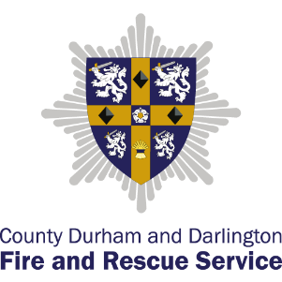
County Durham and Darlington Fire and Rescue Service Headquarters
Belmont Business Park
Durham DH1 1TW

Tel: 0345 3058383
www.ddfire.gov.uk

Document updated: 15 July 2026

