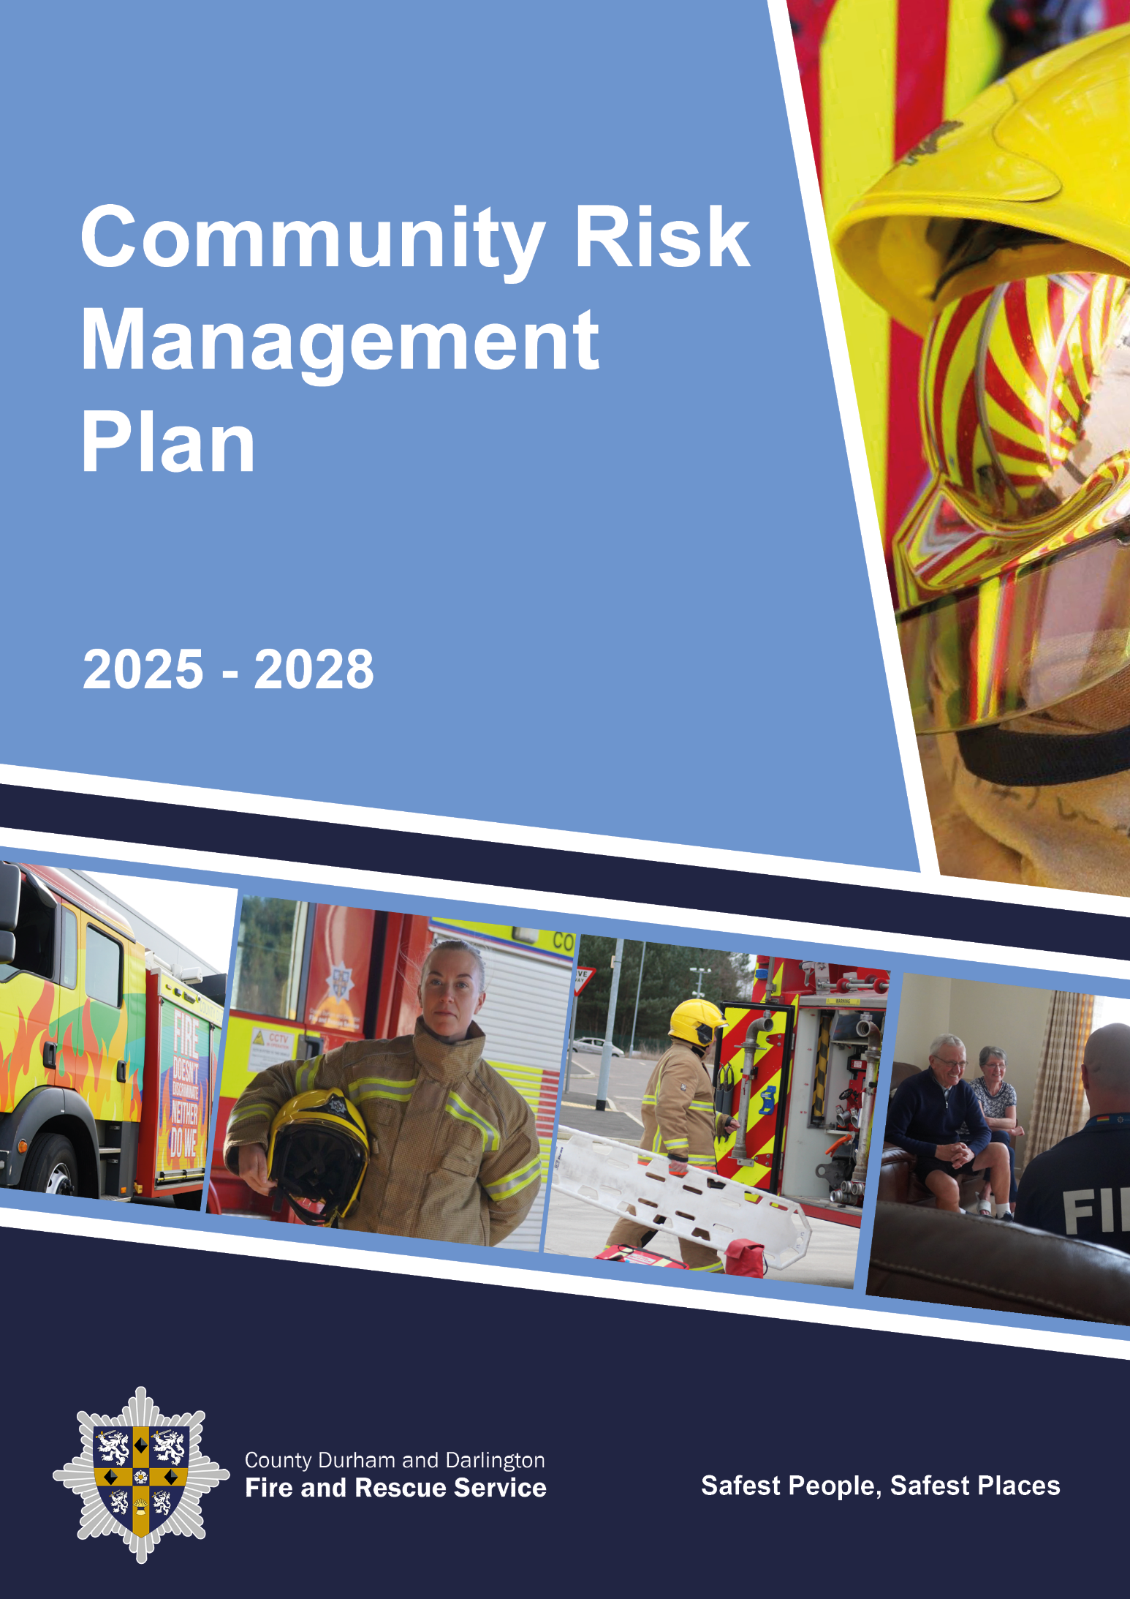

Community Risk Management Plan 2025-2028

Foreword from the Chair and Chief Fire Officer

Welcome to the Community Risk Management Plan for County Durham and Darlington Fire and Rescue Service.

Our Service, governed by the County Durham and Darlington Combined Fire Authority is responsible for making sure that all our communities are protected as far as possible from the risks we face. As well as fire emergencies we are here to respond to many types of incidents such as water and animal rescues, flooding and road traffic collisions. Our protection and prevention work forms the foundation of what we do to minimise risk and together with our essential emergency response function we maintain services which are effective and resilient.

Our vision is to have the safest people and safest places and we will always strive to achieve this by delivering a professional, innovative and effective fire and rescue service, and by placing our communities at the heart of everything we do.

To ensure we are accountable to you, we produce a series of documents which set out our plans for the future. The Community Risk Profile (CRP), together with our Station Plans, sets out the risks we face.

This Community Risk Management Plan (CRMP) is the document which outlines how we keep you safe. Our CRMP shows how we allocate our resources to tackle those risks and our Service Strategies show you the detail of how we will manage the challenges that our departments face.

You can find all our Service Plan documents on our website.

Every year we ensure that our services can be delivered within the budget we are set. Funding challenges and continuing rising costs mean that we expect to face a very difficult financial climate in light of the current economic conditions with a reduction from the Central Government grant, and restrictions on the amount of income we can raise through Council Tax. The next three years are therefore likely to require further innovation and changes to the way we operate, and this CRMP will help us to achieve this.

Our core strength is our people, who are proud to work for an organisation connected closely with its communities and who are genuinely committed to changing and saving people’s lives. We cannot provide our services without support from our excellent staff, and we thank them for their continued hard work and dedication. Our partner organisations and neighbouring Fire and Rescue Services (FRS) also deserve great credit for supporting and collaborating with us in the work that we do.

Executive summary

The CRMP sets out the strategic plans for the Combined Fire Authority (CFA) for County Durham and Darlington and links closely to our other strategic planning documents. The CRMP explains how we are accountable to our local communities through the CFA and through a wide spectrum of local community groups.

Our CRP, which is reviewed annually, describes the greatest risks and their impact on County Durham and Darlington. The CRMP planning process is informed by the CRP as well as our localised Station Plans. By identifying, assessing and managing existing and emerging risks we can decide how best to mitigate them using the resources we have available. We do this by investing in efficient, effective and innovative prevention and protection activities, while also planning the most effective way to respond.

We produce a Medium-Term Financial Plan (MTFP), which considers a range of possible financial scenarios in an uncertain future. The Service has plans that balance the budget in the short term, and contingencies for the medium to long term.

Within this CRMP you will find a number of commitments which offer reassurance that our communities will be provided with the best possible FRS within the available funding. We also stress our commitment to playing our part in tackling climate change and the impact this will have on our environment.

Some of the risks which our communities face are extremely complex and require us to work with a range of partner organisations and other FRSs. Working together supports us to deliver more efficient, effective and resilient support services and we commit to collaborating where there is clear benefit.

Ensuring that we have a highly skilled and professional workforce is a key priority for the Service, and our plans include the use of the apprenticeship levy and career progression framework to develop staff. We are seeking to increase diversity in our workforce through a range of innovative methods, as we recognise that we need to have a workforce reflective of our community. Our commitment to our staff is to maintain a positive organisational culture through continuous improvement. This will ensure that we continue to be successful, despite the challenges ahead.

Our plans are developed in consultation with our communities and partner agencies, as well as our staff and their representative bodies. We are committed to listening to your views and will hold a consultation exercise every year on our plans for the immediate future.

The Challenge Ahead

Our ongoing challenge is to address the risks we’ve identified in our area, with fewer resources.

When we talk about risk, we mean the potential for emergencies to occur – which includes everything from fires and road traffic collisions (RTCs) to flooding and terrorism. You will see more detail about how we deal with risk throughout this document.

Our greatest resource is our people, and we can afford far fewer of them because of a significantly diminished budget. We would prefer to have the level of resources available in other FRS. The Government works out our funding using a formula which favours high density population areas and this means County Durham and Darlington end up less well provided for than elsewhere.

As is the case with all public services, we must work within our available budget. Our revenue budget has reduced considerably over recent years and a government grant of £1.3million which supported capital projects such as replacing older fire engines or modernising our estate was removed in 2013. Over the years there have been reductions in the funding we receive from Government and a limit on the amount of Council Tax available before a referendum takes place, which for 2025/26 will be £5 on a band D property. This has placed considerable pressure on our finances. We know we are facing further financial pressures in the future including increases in costs for the services we buy, the demand on our budget due to unfunded pay awards to staff, significant increases to our energy and fuel bills and limited revenue from council tax.

We are continuing to explore opportunities for making savings elsewhere, this includes the potential for reducing spending on items other than pay, scrutinising every job vacancy which arises to ensure that the position is genuinely required and collaborating with other public services to save money, provide better overall value for money and improve service delivery when we buy services and equipment.

We’re investing more in digital technology in a bid to modernise and automate paper-based processes, which we believe will help improve productivity and help our frontline staff become more efficient in aligning their productivity to risk.

We are proud of County Durham and Darlington Fire and Rescue Service (CDDFRS) as we are one of the most productive FRS’s in the Country, and we have some of the lowest levels of fires within the home or within business premises due to our proactive prevention and protection work. We recognise and work hard to ensure that CDDFRS remains the fastest ‘Predominantly Rural’ FRS in England to respond to life risk incidents. Our proposals aim to protect this position and ensure our current fire engine provision is maintained, balancing resources against risk and demand, with less staff and money.

We believe this matters to our communities and we have invested significant time in engaging with our local MPs, elected members and those in key government departments, including the Fire Minister, to highlight our disproportionate funding challenges.

We hold limited financial reserves (among the lowest of all stand-alone fire and rescue authorities) the majority of which are earmarked for specific purposes. Our reserve strategy is robust, supporting limited investment to replace equipment and modernise uneconomic buildings and practices however, our low level of reserves means that the use of reserves to fund our revenue budget on an ongoing basis is not an option.

What is a Community Risk Management Plan?

The CFA has a statutory responsibility, under the Fire and Rescue Services Act 2004, to produce an Integrated Risk Management Plan (IRMP) – which we call the Community Risk Management Plan (CRMP). The plan must cover a three-year period, be reviewed regularly and outlines how CDDFRS will tackle and mitigate the risks our communities face. The CRMP is informed by our Community Risk Profile (CRP), a document which assesses in detail the risks in our local areas, how likely they are to occur, how extensive the impact might be and also takes into account national risks. We use the National Risk Register and the Local Resilience Forum Community Risk Register, community data and our own data to help us prepare the CRP.

As an over-arching plan the CRMP covers all parts of our Service, so it references our Service Strategies and other key documents such as our Station Plans, and it even links to our appraisal system. This helps everyone in our organisation to understand risks and how we plan to reduce the impact and respond effectively.

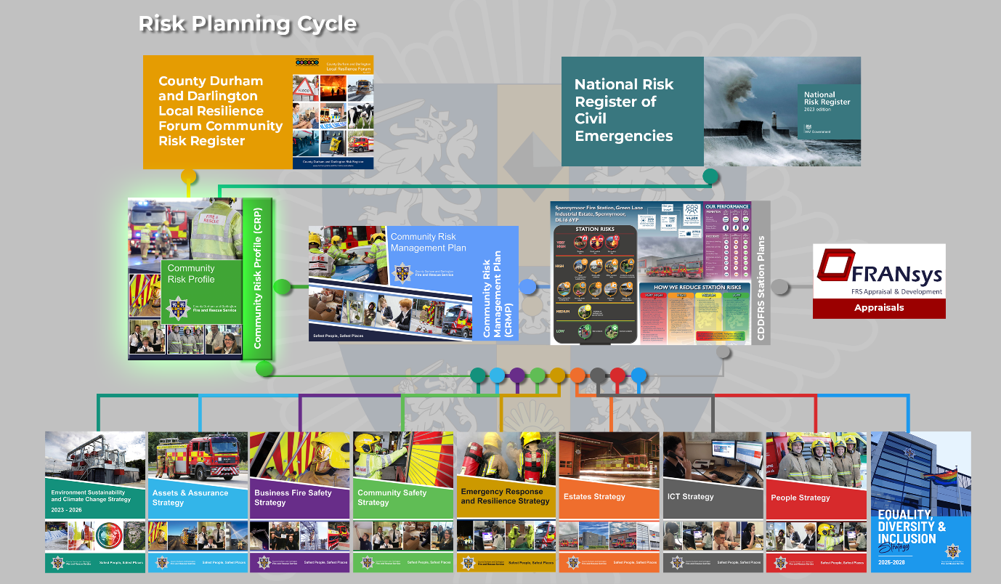

The requirements of a CRMP are set out in the ‘Fire and Rescue National Framework for England 2018’, (in which the document is called an IRMP). This states that each Authority must ensure the following five priorities are met:

1. To be accountable to communities for the service they provide;

2. To identify and assess the full range of foreseeable fire and rescue related risks their areas face;

3. To make appropriate provision for fire prevention and protection activities and response to fire and rescue related incidents;
4. To develop and maintain a workforce that is professional, resilient, skilled, flexible and diverse;

5. To collaborate with emergency services and other local and national partners to increase the efficiency and effectiveness of the service they provide.

You will find details of how we address the above points throughout this document.
The National Framework also says that CRMPs have a statutory responsibility to contain a number of areas including an outline of how we allocate our resources to mitigate risks, and how we manage and enforce the Regulatory Reform (Fire Safety) Order (FSO) 2005. You can learn more about our legal duties by reading the National Framework.

The CRMP will also show you how we consult with you – our communities – on the development of this plan, as well as how we seek the opinions of our staff, representative bodies and partner organisations.

This document covers the period April 2025 to March 2028 and is reviewed on an annual basis making sure our plans are always up to date and reflect changes in national and local risks, our policies and finances.

Vision and Values

We want to have the safest people and the safest places.

To respond effectively to the challenges that we face here at CDDFRS, we need to be clear on our strategic direction. A defined vision, strategic priorities, values and behaviours are key to us doing this.

Our strategic priorities:

Our overall focus is to identify, assess and manage risks while ensuring that resources are allocated efficiently and effectively to reduce the number of emergency incidents and the associated risk of injury or death across our Service area.

To help us to achieve our vision, we have six strategic priorities. These are

Emergency Response
Business Fire Safety
Community Safety
Value for Money
Working Together
Our People, Our Way

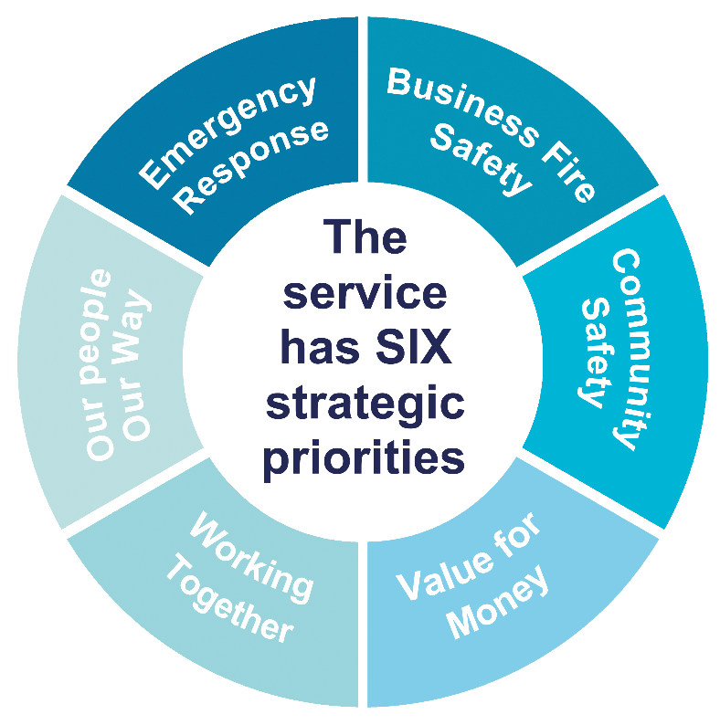

You can read more about Our Priorities on our website.

Our values:
These values are known in our organisation as the PIE values (Professional, Innovative, Effective) and describe the ethos of CDDFRS.


The range of these behaviours falls into four areas, which we call the 4Cs:

How we approach challenges

We will approach challenges with flexibility, enthusiasm and motivation, passion, determination and resilience.

How we conduct ourselves

We will conduct ourselves in a manner that is honest, trustworthy, reliable, accountable, consistent and respectful.

How we collaborate with others

We will be approachable, supportive, encouraging and inclusive, and value development when collaborating.

How we drive change across the organisation to make a difference

We will drive change by being creative, resourceful, courageous, original, clear and focused.

Our staff work to a Code of Ethics which is aligned to the National Fire Chiefs’ Council code.

Our commitment to you - Be the Best

Recruit and retain a diverse workforce and continually assess their performance and behaviours.

His Majesty’s Inspectorate of Constabulary and Fire and Rescue Services

His Majesty’s Inspectorate of Constabulary and Fire and Rescue Services (HMICFRS) has a remit to inspect all 44 FRSs in England. Every year HMICFRS publishes a review of the sector in the State of Fire and Rescue report.

The HMICFRS’ assessment examines the Service’s effectiveness, efficiency and how well it looks after its people. It is designed to give you information about how your local FRS is performing in these three key areas, in a way that is comparable with other FRSs across England.

We are judged by HMICFRS and given ratings for each pillar: outstanding, good, adequate, requires improvement or inadequate.

Our last inspection report was published on the 20 January 2023, and we were rated as good at providing an effective and efficient service and how well we look after our people.

About our Service area

We look after the areas of County Durham and Darlington, which cover approximately 939 square miles with a population of approximately 630,000 people. We protect around 302,500 households and 20,150 business and other premises. We have a mixture of rural, urban and coastal areas so our prevention and protection work, as well as our emergency response, has to be tailored to the differing needs of each type of community.

We have 15 fire stations. These are:

- Barnard Castle
- Bishop Auckland
- Consett
- Crook
- Darlington
- Durham
- High Handenhold
- Middleton in Teesdale
- Newton Aycliffe
- Peterlee
- Seaham
- Sedgefield
- Spennymoor
- Stanhope
- Wheatley Hill

We border five other Fire and Rescue Services (North Yorkshire, Cumbria, Northumberland, Tyne and Wear and Cleveland), providing mutual cross-border support to one another if and when required.

About our communities

We recognise that we can only provide an effective service if we understand the diversity within our area and enable our workforce to meet the needs and concerns of people who live, work, study and visit County Durham and Darlington.

Our CRP highlights the challenges faced by the public relating to deprivation and health, as well as the make-up of our population in relation to age, gender and ethnicity.

Our rural communities cover a significant geographical proportion of the Service area, with some individuals extremely hard to reach and therefore at more risk of being vulnerable.

Health inequalities remain persistent and pervasive, with levels of deprivation being significantly higher and life expectancy here is lower than the national average. We know that living in isolation can have a negative impact on a person’s health and well-being. We have also witnessed first-hand how poor-quality housing can exacerbate a range of underlying health conditions, from falls and poor mental health to hoarding and excessive alcohol and substance misuse.

The following Health Profile information highlights some of the challenges our communities face:

Life Expectancy:
Life expectancy for males is 78 and for females is 81, both lower than the England average.

Adults:
The number of people aged 65 and over in County Durham and Darlington is 133,713 which is 21% of the population. This is higher than the England average of 18.4%. (Census Data 2021)

Dementia:
5,490 people were diagnosed with dementia in County Durham and Darlington. (Fingertips Public Health Profiles 2022)

Physical problems:

On average 77.7% of people living in County Durham and Darlington over the age of 18 are classified as overweight or obese. (Fingertips Public Health profiles 2023), worse than the England average of 64%.

Suicide:

The rate of deaths by suicide for County Durham and Darlington is 16.4 deaths per 100,000 people, higher than the England average of 10.7 per 100,000.

Smoking:

In Durham 11.7% of adults are smokers, in Darlington this figure is 8%. The England average is 11.6%

Children:
Within our area, the level of child poverty is worse than the England average (19.9%), with 25.5% of children under 16 years living in relative poverty (Public Health England 2021/22).

Indices of Multiple Deprivation:

Out of the 317 Local Authorities in England, Durham ranks 70th in the league table of the most deprived and Darlington is 49th where 1 is the worst and 317 is the least.
The service area has 51 Lower Layer Super Output Areas in the 10% most deprived decile. 39 are in County Durham and 12 in Darlington.

What We Do – Prevention

Preventing fires and other dangerous incidents is as important to us as responding to them. We invest significantly in our prevention work which includes going into communities, schools and homes to give fire safety advice, as well as running safety campaigns.

We have a dedicated Community Safety and Arson Reduction Team to deliver our preventative activities, and this work also forms a large part of the day-to-day activities carried out by our firefighter crews. We deliver Home Fire Safety Visits (HFSVs) which includes installing smoke alarms through to giving in depth advice and materials to support people in our local areas who are at high risk of a fire starting. HFSVs allow us to target our most vulnerable people in society and we have well established relationships with our partner agencies to encourage referrals of people who are most at risk.

In 2023 our hard work was rewarded by the fantastic achievement that we were the fourth highest FRS for the delivery of HFSVs per 1,000 population across the UK (Home Office data).

Prevention also covers our campaigns on activities such as road safety, water safety including cold water shock and working in partnership with other agencies to reduce community risk.

The Service faces a longstanding challenge with the setting of deliberate fires and has seen 2,604 deliberate primary and secondary fires in 2023-24, which was particularly high due to the heatwave experienced in the region. We have increased investment in arson reduction and engagement with children and young people. Our work includes proactive patrols in hotspot areas, visiting schools, taking referrals to work with higher risk young people and attending community events.

You can learn more about our Community Safety work on our website.

Reaching our most vulnerable people

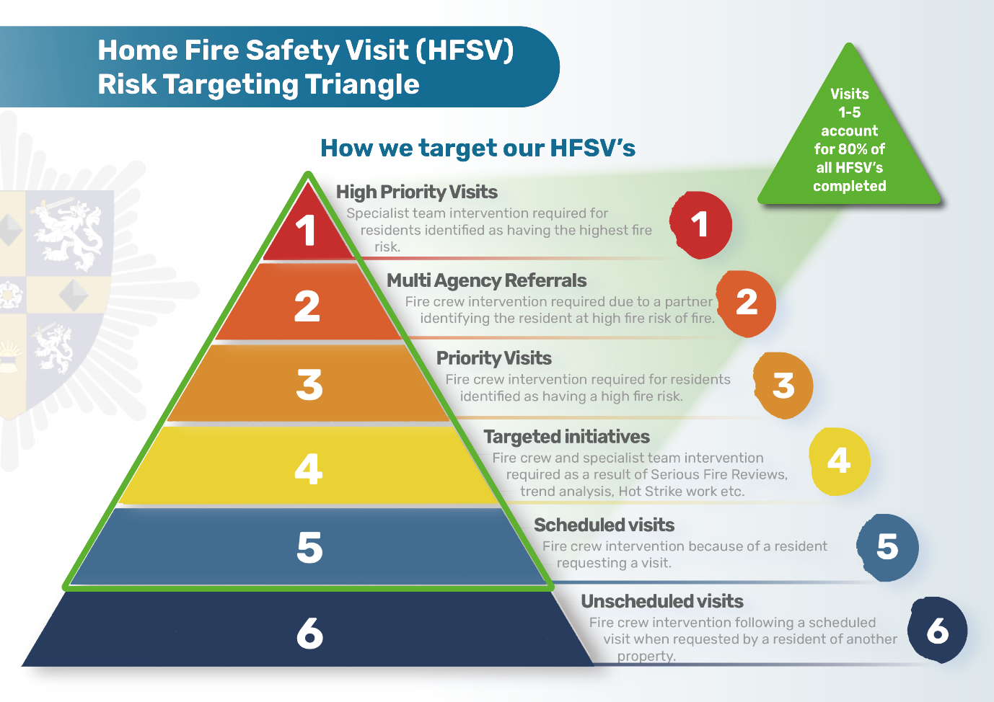
Following consultation with you we are continuing to focus our attention on reaching the most vulnerable members of our communities who are at the greatest risk of having a fire in their home.

We start by looking at different types of data and then assessing people and property in terms of risk levels, with level one being the most vulnerable, and level five the least. This analysis ensures we focus our HFSVs in the right areas, to the right people, at the right time.

We will continue to seek and receive high-risk and safeguarding referrals from partner agencies such as community nurses, social workers, carers and social housing providers that work in our communities on a daily basis and are therefore in a unique position to signpost vulnerable individuals to us.

Community Safety Successes
This year our Community Safety and Arson Reduction Team went the extra mile by creating and delivering an 11 week targeted programme which led to young people achieving a Prince’s Trust Level 1 Award in Developing Resilience. This fantastic programme was in collaboration with The Key Project and enabled with funding from the Police and Crime Commissioner for Durham and Darlington.

Last year, we delivered 18,290 Home Fire Safety Visits (HFSVs) 95.3% of which were completed by our operational crews. 99% of these visits were delivered to high-risk people or properties.

Our investment in HFSVs particularly over recent years has helped towards achieving an overall reduction of accidental dwelling fires (ADFs). We recognise our activities and investment has saved lives and reduced the devasting impact that fires in the home bring. 2023-24 saw the Service record that we attended 199 accidental house fires, the second lowest in 11 years, where the number was nearer to 300.

As a result of the HFSVs carried out, in 2023-24 we made 461 onward lifestyle referrals to our partners.

At CDDFRS, our links with our local communities are strong. Our Eyes Wide Open initiative is designed to empower those who work within our communities to identify individuals most at risk of fire and refer them to us. By doing so, we extend our reach in identifying vulnerable individuals and providing them with life-saving advice and equipment to keep them safe in their homes.
This initiative is specifically targeted at people who regularly work within our communities and within people’s homes for example carers, support workers, and volunteers.

Previously delivered in person, this year the training has now been modernised into a comprehensive and accessible digital training video. This enhancement allows us to deliver the training to a wider audience more efficiently. Upon successful completion, they are certified as Eyes Wide Open Ambassadors, ready to play a vital role in safeguarding the most vulnerable members of our community. This initiative represents our commitment to collaboration and innovation in creating safer homes for everyone.

Our commitment to you - Prevent
Target at least 80% of our HFSVs to the most vulnerable people, taking referrals from and making them to our supporting partners.

What We Do - Protection

Business Premises
The Fire and Rescue National Framework for England (2018) states that FRA must make provision for promoting fire safety, including fire prevention. To do this we have a strategy for providing advice to businesses, conducting fire safety audits and where necessary enforcing compliance with the Regulatory Reform (Fire Safety) Order 2005 (we call this the FSO). These inspections are carried out by our central Business Fire Safety team for higher risk premises, and operational crews carry them out if the level of risk is medium or low.

Our Business Fire Safety work involves us visiting commercial premises to conduct fire safety audits, which form part of what is known as our Risk Based Inspection Programme (RBIP). Following your response to our CRMP 2023/24 consultation we have reviewed our RBIP and implemented an updated programme on 31 March 2024. This new RBIP has an increased focus on premises types identified as a higher risk through national research. This included care homes, hotels, hospitals and residential buildings over 4 storeys.

Additionally, our management Information System (CFRMIS) further develops our RBIP through an algorithm which takes into account factors such as premises type, building size, compliance rating, and occupation numbers to calculate a relative risk rating for other premises types and identifies appropriate inspection frequencies for high risk premises.

The RBIP covers large manufacturing companies, student residences, care homes
and small businesses such as shops and food outlets. We are also a statutory consultee on building regulations and licensing applications to ensure buildings comply with legislation and remain safe for occupants. This is a vital tool in keeping you safe. We also have a range of enforcement powers which we use with the aim of keeping occupants safe or to reduce the risk of a fire.

We work with businesses to help them in their compliance with legislation and will take enforcement action to ensure that people who work in and visit premises across County Durham and Darlington remain safe.

We carried out 1,716 fire safety audits between April 2023 and March 2024, 88% of which were completed by our operational crews. We continue to invest resources to protect businesses and are confident that the inspection programme has returned to pre-pandemic levels. 479 business regulation consultations took place during the same period, while we also reviewed 197 licensing applications.

Our continued investment in Business Fire Safety has paid dividends and we are proud to be amongst the highest performing FRS for the delivery of fire safety audits per 100 business premises, with HMICFRS noting that we undertook almost five times the England rate for fire safety audits per 100 known premises (9.66 audits per 100 known premises compared to the England rate of 2.0). This has resulted in a continued decrease in the number of fires within premises regulated by the FSO via the FRS.”We continue to work in partnership with other enforcing agencies such as the Crown Premises Fire Safety Inspectorate, who ensure Crown controlled premises such as the Prison Estate comply with the FSO.
We proactively work in partnership with Building Control, Planning, Immigration and Licensing to share relevant information to reduce risk and harm.

We have continued to train our crews to achieve a Level 3 Certificate in Fire Safety so that we comply with the Competency Framework for Fire Safety Regulators.

Staff have also undertaken a great deal of engagement work with businesses, including online seminars.

Through the active targeting of our RBIP we have seen an increase in the number of unsatisfactory audits between 1 April 2023 to 31 March 2024 as 44.2% of all fire safety audits were unsatisfactory, which provides assurance that we are inspecting the right premises and making safety improvements.

Our commitment to you - Protect
Work with local businesses to keep people safe from fire and take enforcement
action when we need to.

What We Do – Response

We do all we can to prevent and protect but if something goes wrong, we are always here to respond to you if you need us. CDDFRS is proud to say that we are one of the fastest services to answer emergency calls and deploy fire appliances, and we are the fastest to respond amongst all predominately rural FRSs.

The total number of emergency calls received in 2023-24 was 15,756. There were 2,604 deliberate fires in 2023-24. Breaking it down even further, 563 of these were deliberate primary fires, while 2,041 were deliberate secondary fires. This shows a similar number to the previous year, and we therefore continue to recognise that in the North East the number of deliberate fires is well above the national average and we are working with our partners across the region to reduce these.

We attended 199 Accidental Dwelling Fires (ADFs) during the same period, a figure which is down from 292, 11 years ago. These resulted in 7 deaths and 16 injuries that required hospital treatment.

There were 106 fires in non domestic premises, with 28 occurring in locations where CDDFRS does not enforce the Fire Safety Order. Of these, 27 were in prisons, which are nationally recognised for experiencing significantly higher levels of fire incidents compared to other categories of non-domestic premises. Of the 106 fires, no injuries were recorded.

We responded to 335 Road Traffic Collisions (RTCs) between April 2023 and March 2024.

The total number of false alarms we received was 2,480. Of this number, 710 were caused by automatic fire alarms within non domestic premises, whereas 64 were malicious in nature. We have a charging policy which aims to reduce the impact of automatic fire alarms (AFAs) on businesses on our Service. We have also reviewed our policy on responding to AFAs from non domestic premises which means from 2 October 2023, we have responded to less false alarms at these premises. This decision has increased our fire appliance availability to respond to life risk incidents, helps to reduce our environmental impact by minimising blue light journeys and increases the overall productivity of our operational staff.

Special Service calls account for 1,174 incidents in 2023-24, with some of the most frequent incidents involving medical assistance, RTCs, gaining entry into property, assisting other agencies and flooding.

Although the Service makes every effort to avoid incidents from occurring through its proactive work, we are also realistic in acknowledging that we will always be required to respond to emergency incidents. Where this is necessary, however, we ensure control measures are in place to mitigate the impact on everyone involved.
Through this process, we are committed to evaluating and reviewing all our work, implementing continuous improvements along the way.

Our commitment to you - Respond
In an emergency we will be fully prepared to respond and will strive to reduce the
impact.

How are we performing?

Performance is scrutinised across the organisation. The CFA regularly monitors the performance of the organisation through its Performance Committee. The Service has a Performance Board which tracks data across the organisation and provides the same performance reports to the Service Leadership Team (SLT) and Performance Committee, ensuring thorough scrutiny.

You will see our results throughout this document but for more detailed information on our performance over the last three years visit the Our Performance page on our website.

Achievements and Innovation

The Service is immensely proud of the fact that it has led the way with a national award-winning Firefighter Apprenticeship Scheme, which was launched in 2017.
The Service welcomed its seventh cohort of Apprentices beginning their journey in 2023 and are currently recruiting for cohort eight who will start in Spring 2025.

The scheme itself was named as The Best Apprenticeship Scheme in the UK at the Training Journal Awards. In 2020 the Scheme also won the Accenture Award for Recruitment Excellence of the Year at the National Apprenticeship Awards, an outstanding achievement. In 2022 the Service was named in the Department for Education’s top 100 apprenticeship employers, and in 2023 we were ranked 26th. The Service also achieved the Investors in Apprenticeships platinum award in 2024 which demonstrates our commitment in this area.

As part of the Service’s estates improvement programme our Wheatley Hill Station has been upgraded to provide staff with improved facilities and is a key community resource for the village.

The Service continues to invest in its workforce through the Talent Management Framework which develops staff at all levels into effective and supportive leaders.

The Service is a Disability Confident Leader and holds the Better Health at Work Award at Ambassador status, which demonstrates our commitment to the well-being of our workforce. Meanwhile, we are also proud to have signed the Armed Forces Covenant and been accredited with Gold status in the Employer Recognition scheme, which we achieved reaccreditation in 2024.

Staff can also receive a commendation or certificate of appreciation from the Chief Fire Officer for conduct that is over and above the usual expectations of their role.

We are very proud of our staff’s fantastic hard work and achievements.

We have made significant strides in enhancing firefighter productivity and efficiency through innovative use of AI, data analysis, and strategic communication.
The development and implementation of the firefighter utilisation app and Power BI dashboard have notably improved operational efficiency and resource allocation.

Recognising the lack of a standardised approach to monitoring firefighter productivity, we commissioned a comprehensive project in 2023 to improve firefighter utilisation. The project involved developing a PowerApp for operational staff to input data, which was then analysed using Power BI.

We have also developed a scheduling assistant using AI and workload modelling.
This tool allows for a systematic and proactive approach to resource allocation, ensuring activities are scheduled based on specific risks associated with each station area. Historical incident data and the Community Risk Profile (CRP) are analysed to create actionable schedules, targeting activities to mitigate risks and enhance productivity.

Next steps include refining existing data sources, incorporating additional data such as weather conditions and socio-economic factors, and integrating risk-based inspection programmes. This will ensure that the most vulnerable residents are reached and that productivity continues to align with identified risks.

Our commitment to you - Improve
We will constantly endeavour to improve by monitoring our performance and
encourage our staff to be innovative.

Governance

How are we accountable to our communities for the service we provide?

Locally
Our CFA consists of 25 elected councillors; 21 from Durham County Council (DCC) and 4 from Darlington Borough Council (DBC). The CFA is the legal body with statutory duties and responsibilities for:

- Ensuring the Service is effective and efficient;
- Setting the strategic direction, policies and procedures of the Service;
- Holding the Chief Fire Officer to account for the effective and efficient running of the Service.

The CFA has a number of subcommittees with delegated powers that look at specific areas such as audit and finance, human resources and performance. CFA Members operate under our Constitution and Code of Corporate Governance, as well as a dedicated Code of Ethics, which is aligned to the jointly endorsed National Fire Chiefs’ Council (NFCC), Local Government Association (LGA) and Association of Police and Crime Commissioners (APCC) Code.

You can read more about the CFA, how it works, and papers from meetings on our website.

We have representatives on all 14 of the Area Action Partnerships in the Service
area who link directly with elected members and community representatives across County Durham. We are a member of the Darlington Partnership, and we also liaise with Parish Councils.

We publish a range of information on our website including, Financial Governance, Annual Governance Statement; Statement of Accounts and our Performance information. In addition to our strategic documents which are available for the public to scrutinise.

Our staff work under a Code of Conduct for Employees which governs the standards we expect and ensures accountability to you. This was refreshed in 2022 to reflect the introduction of the National Fire Chiefs’ Council Core Code of Ethics You can read the Code of Conduct which incorporates the national Core Code of Ethics, in our Constitution.

Statement of Assurance

The annual Statement of Assurance provides the necessary accountability and transparency to the people of County Durham and Darlington and is evidence that their FRS continues to deliver in accordance with the expectations detailed within both the Fire and Rescue National Framework for England 2018 and our own CRMP process.

It also details the measures taken to assure our communities that the CFA’s performance is efficient and effective in relation to finance and governance.

It measures operational assurance to demonstrate that our services are delivered in line with our statutory responsibilities and with due regard to the expectations set out in our CRMP, including cross-border, multi-authority and national incident arrangements.

You can read the annual Statement of Assurance on our website.

Our commitment to you

Learn
We will learn and improve following scrutiny from HMICFRS, the CFA, external audit bodies and our consultation process

How we identify risk

How do we identify and assess the full range of foreseeable fire and rescue related risks our areas face?

When determining how we identify risk, we first have to take into account a number of key documents which cover national, regional and local risks. These documents feed into our ‘Community Risk Identification Process’. We talk to our crews on the ground, senior officers, partner agencies and other responder organisations to help us to better understand the risks in our community.

We use the latest version of the updated National Risk Register to assist us in aligning the risks we see locally to those which are identified by experts at national level. Our Local Resilience Forum (LRF), which is chaired by our Chief Fire Officer and is made up of all the key local stakeholder organisations that deliver responses to major incidents, also produces a Community Risk Register and we make sure our risks also align with these.

In addition to monitoring national, regional and local risks, our Community Risk Profile (CRP) provides an in-depth piece of research and analysis of the incidents we have attended over previous years, and the risk of emergency incidents occurring in the future. This document is refreshed annually.

We have access to a variety of useful data which helps us to know where our risks are and to identify trends and demand. We use a number of datasets associated with elevated risk which involves profiling geographical areas, businesses, dwellings and individuals by combining data from past incident activity and other demographic data such as age, deprivation and lone households.

The first stage of our risk assessment methodology used within the CRP is to identify incidents that can cause harm to the people, environment and economy within our communities, using various data sources and tools. We also utilise a nationally recognised risk assessment matrix based on a reasonable worst-case scenario, with an assessment of the likelihood and impact in order to come to definitive scoring.

Understanding national risks, together with our CRP and Station Plans, helps us plan our emergency response. The Service also has a Corporate Risk Register that looks at all the risks to our business (service provision and financial). These risks are monitored with measures put in place to ensure we can fulfil our role as a FRS protecting the communities of County Durham and Darlington.

Areas of business are addressed through one of our strategic priorities. The purpose of these priorities is to define a simple practical framework to manage risk, while highlighting how the Service intends to mitigate these risks on an ongoing basis through a detailed action plan.

A comprehensive understanding of risk and demand enables the Service to allocate our prevention, protection and emergency response resources appropriately. We then consider how the productivity of our workforce is aligned to dealing with our greatest risks.

You can read more about this in the Community Risk Profile.

Our commitment to you
Plan
We will identify the risks you face and plan ways to reduce their impact using our staff and resources effectively.

Community Risk Identification Process

The infographic below shows the cycle we follow each year as part of our risk planning and management. It contains the following documents:

- National Risk Register of Civil Emergencies
- County Durham and Darlington Local Resilience Forum Community Risk Register
- CDDFRS Community Risk Profile
- CDDFRS Community Risk Management Plan
- CDDFRS Strategies
- CDDFRS Station Plans
- CDDFRS Appraisal System

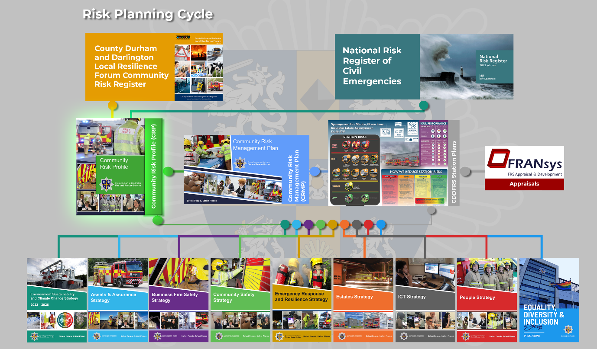

What are the risks we have identified?

Our CRP identifies the main risks within County Durham and Darlington and further details of the proactive and reactive measures are contained within our Station Plans.

Risk 1 Dwelling fires

Every year, we experience fires in people’s homes that are devastating for those people involved and can cause injury and death.

Proactive measures
We will:
- Provide equipment and training for crews
- Identify those people most at risk/vulnerable
- Conduct HFSVs, fit smoke alarms and provide fire-retardant equipment focusing on fire safety messaging which reduces the likelihood of an accidental fire and educate those within the property to reduce the spread of fire within the home if one should occur
- Refer people to other agencies where vulnerability is identified
- Arson reduction and fire setter interventions
- Attend national events to establish best practice
- Conduct regular evaluation of our work in relation to dwelling fires

Reactive measures
We will:
- Attend 70% of all dwelling fires within eight minutes
- Provide advice after the fire and carry out hot strikes
- Utilise support, if required, from Red Cross Fire Victim Support Teams
- Investigate the cause of fires at the appropriate level in partnership with the police
- Where appropriate, submit post-incident safeguarding referrals
- Conduct performance-management processes to identify trends in incidents

Risk 2 Other residential building fires

Other residential building fires are a classification of primary fires and includes institutional properties such as hostels for homeless people, hotels and B&Bs, nursing/care homes and student halls of residence.

Proactive measures
We will:
- Provide equipment and training for crews
- Use data to understand which premises present the highest risks
- Deal with complaints and enquiries
- Carry out fire safety audits to ensure compliance with the Fire Safety Order
- Adopt a continuous re-inspection programme based on risk levels
- Use enforcement action where required
- Work with businesses to ensure they keep their premises safe
- Conduct regular evaluation of our work in relation to these types of incidents

Reactive measures
We will:
- Investigate the cause of fires at the appropriate level in partnership with the police
- Carry out post-fire audits to offer advice
- Consider enforcement action where necessary
- Deal with complaints
- Charge businesses for Unwanted Fire Alarms
- Work with partners to mitigate the impact of these incidents on the environment
- Ensure we have secured appropriate water supplies, to aid firefighting

Risk 3 Other non-residential building fires

Every year, we experience fires in places such as offices, factories, prisons and commercially operated residential premises.

Proactive measures
We will:
- Provide equipment and training for crews
- Use data to understand which premises present the highest risks
- Deal with complaints and enquiries
- Carry out fire safety audits to ensure compliance with the FSO
- Adopt a continuous re-inspection programme based on risk levels
- Use enforcement action where required
- Work with businesses to ensure they keep their premises safe
- Conduct regular evaluation of our work in relation to these types of incidents

Reactive measures
We will:
- Attend 70% of all non domestic property fires within nine minutes
- Investigate the cause of fires at the appropriate level in partnership with the police
- Carry out post-fire audits to offer advice
- Consider enforcement action where necessary
- Deal with complaints
- Charge businesses for Unwanted Fire Alarms
- Work with partners to mitigate the impact of these incidents on the environment
- Ensure we have secured appropriate water supplies, to aid firefighting
- Work with responsible persons for premises where we are not the enforcing authority e.g. Prisons

Risk 4 Road vehicle fires

Road vehicle fires are a classification of primary fires and are fires in vehicles used for transportation on public roads, such as cars, vans, buses/coaches, motorcycles, lorries and heavy goods vehicles.

Proactive measures
We will:
- Provide training and equipment for crews
- Use the Service data systems and business intelligence to identify areas where vehicle fires occur
- Provide dedicated arson reduction staff to reduce the number of car fires
- Work in partnership with Durham Police to reduce the prevalence of road vehicle fires

Reactive measures
We will:
- Investigate the cause of road vehicle fires
- Work with authorities to prosecute those guilty of deliberately setting fire to road vehicles
- Consider the deployment of Targeted Response Vehicles (TRV), where appropriate, to reduce the demand on other front-line resource

Risk 5 Secondary fires

Across the North East and within County Durham and Darlington higher levels of predominantly outdoor secondary fires occur, the majority of which are as a result of arson. These incident types have a significant community impact, as well as being a drain on the FRS resource that could be deployed elsewhere. Our data indicates the areas of high levels of arson which enables us and our partners to focus our resources effectively.

Proactive measures
We will:
- Provide equipment and training for crews
- Work with partners to reduce the burden on all agencies
- Work with authorities to prosecute those guilty of arson or deliberate fire-setting
- Develop strategies with key partners and evaluate campaigns, education packages and initiatives
- Utilise data analysis software to highlight hotspot areas
- Conduct regular evaluation of our work in relation to primary and secondary fires

Reactive measures
We will:
- Consider the deployment of TRVs, where appropriate, to reduce the demand on other front-line resources
- Conduct arson/ environmental audits with partners in areas subject to high operational activity
- Investigate the causes of fires in partnership with the police
- Conduct Service-wide and local performance management measures to help to identify problem areas or trends

Risk 6 Void and empty properties

Fires involving buildings which are no longer occupied present a significant challenge, especially if the void or empty property is left unsecure, unmanaged, accessible and located in a populated area. When involved in fire, void or empty properties can be extremely hazardous for anyone within the building and responding emergency personnel.

Proactive measures
We will:
- Work with key partners to influence how void and empty properties are managed
- Seek to identify void and empty properties and ensure operational crews have up to date risk information
- Provide training to ensure operational crews are aware of the dangers associated with void and empty properties
- Use the Service data systems to identify hotspot locations of void and empty properties

Reactive measures
We will:
- Work in partnership and apply interventions to reduce the prevalence of fires involving void and empty properties
- Investigate the causes of fires in partnership with the police

Risk 7 Wildfires

Wildfires can quickly escalate and spread across large areas, causing major disruption to life, property and infrastructure.

Proactive measures
We will:
- Provide equipment and training for crews
- Work with landowners and responsible authorities to reduce the risk of widespread wildfires
- Promote the potential dangers of starting fires in rural locations such as barbeques or campfires
- Train our staff to provide expert advice
- Conduct regular evaluation of our work in relation to wildfires

Reactive measures
We will:
- Deploy appropriate resources to contain and extinguish wildfires
- Deploy specialist wildfire personnel and equipment as appropriate
- Request assistance from other agencies and organisations for specialist equipment as required
- Consider mutual aid requests where necessary to assist with large or protracted incidents

Risk 8 Rescues from water

The rivers, lakes and other areas of open water throughout the Service area present a risk when members of the public enter flowing or static water, get into difficulty, and require rescuing by fire and rescue service personnel.

Proactive measures

We will:
- Provide training and equipment to deal with water related incidents
- Identify the locations of water risks throughout the Service area
- Respond to water related incidents and carry out rescues of people requiring assistance
- Work in partnership to reduce the risk of water related fatalities
- Campaign to members of the public to educate them about the dangers posed by bodies of water
- Make a specialist water rescue team available to respond locally and nationally
- Conduct regular evaluation of our work in relation to water related incidents

Reactive measures

We will:
- Debrief these types of rescues to identify the opportunity for organisational learning to improve service deliver

Risk 9 Rescue from height

Incidents at heights could occur in many different formats and anywhere across the Service area. The dangerous nature of dealing with such incidents leads to an increased risk of injury to anyone involved.

Proactive measures
We will:
- Provide equipment and training for crews
- Work closely with partner agencies such as mountain rescue, coast guard and other FRSs
- Provide a specialist capability to respond to the most challenging rescues
- Conduct regular evaluation of our work in relation to height rescues

Reactive measures
We will:
- Deploy specialist line rescue teams supported by additional fire crews to effect rescues
- Utilise specialist engines such as the aerial ladder platform (ALP) to assist with rescues
- Work in partnership to assist with the resolution of incidents
- Support other agencies to assist vulnerable persons involved in height incidents
- Debrief these types of rescues to identify the opportunity for organisational learning to improve service delivery

Risk 10 Road traffic collisions (RTCs)

Deaths and serious injuries on the road affect County Durham and Darlington residents each year as well as people from further afield.

Proactive measures
We will:
- Provide equipment and training for crews
- Work with our key strategic partners to reduce risk through education
- Utilise local and national data sets on RTC numbers and type
- Attend national and local working groups that share best practice
- Provide crews with the latest technology to meet the modern methods of vehicle construction
- Conduct regular evaluation of our work in relation to RTCs

Reactive measures
We will:
- Attend 70% of life-risk RTCs within 10 minutes
- Respond with appropriate resources to RTCs to effect rescue, mitigate the risk from fire and other related risks, and assist partners in resolving the incident
- Respond to non-life risk RTCs on request to help to make the scene safe

Risk 11 Rail incidents

Fires and accidents on the transport network not only present an immediate threat to life and property but can also have a long-lasting impact on infrastructure and our communities.

Proactive measures
We will:
- Provide equipment and training for crews
- Work with our partners to help to improve safety within the transport industry
- Understand the main rail networks within our area
- Conduct operational exercises at high-risk sites/locations
- Collect information and develop plans on our highest transport risks so that we are prepared to respond
- Conduct regular evaluation of our training in relation to rail incidents we attend

Reactive measures
We will:
- Respond to incidents with sufficient resources to effect rescue, deal with fire and other hazards, and assist with casualties
- Request support of specialist fire and rescue teams such as Urban Search and Rescue where appropriate
- Work in partnership to mitigate the impact of such incidents and facilitate recovery

Risk 12 Aircraft incidents

Fires and accidents relating to aircraft not only present an immediate threat to life and property but can also have a long-lasting impact on infrastructure and our communities.

Proactive measures

We will:
- Provide equipment and training for crews
- Work with our partners to help to improve safety within the transport industry
- Understand the main flight paths within our area
- Conduct operational exercises at local airports
- Collect information and develop plans on our highest transport risks so that we are prepared to respond
- Conduct regular evaluation of our training in relation to aviation incidents we attend

Reactive measures
We will:
- Respond to incidents with sufficient resources to effect rescue, deal with fire and other hazards, and assist with casualties
- Request support of specialist fire and rescue teams such as Urban Search and Rescue where appropriate
- Work in partnership to mitigate the impact of such incidents and facilitate recovery

Risk 13 Maritime incidents

These incidents refer to fires on board ships or within the harbour area of the coastline within the Service area.

Proactive measures

We will:
- Provide training and equipment for operational crews to respond to an incident involving sea vessels
- Work in partnership to reduce the impact of an incident occurring within Seaham Harbour
- Provide risk information to operational crews on the risks associated with Seaham Harbour

Reactive measures

We will:
- Debrief these types of fires and rescues to identify the opportunity for organisational learning to improve service delivery

Risk 14 Flooding

Widespread flooding can devastate parts of the community and leaves an impression for years beyond an event. We have also seen some tragic drownings in our waterways over the years and climate change will lead to an increase in such events.

Proactive measures
We will:
- Provide equipment and training for crews
- Develop flood plans and provide operational risk information for crews
- Work with partners to prepare for flood risk
- Campaign to members of the public to educate them about the dangers posed by bodies of water
- Work closely with the Environment Agency (EA) to share ideas
- Make a specialist water rescue team available to respond locally and nationally
- Conduct regular evaluation of our work in relation to water related incidents

Reactive measures
We will:
- Work with partners to protect and maintain critical infrastructure in times of flooding
- Prioritise and respond to domestic flooding calls and assist if appropriate
- Deploy a specialist water rescue team to perform rescues and evacuation of people affected by flooding
- Work with other agencies to help to protect areas at immediate risk of flooding
- Deploy High Volume Pumps (HVP), where appropriate, to areas most affected

Risk 15 Industrial incidents and fires

There are many industrial premises amongst the villages and towns in the Service area, which if involved in fire can have the potential to affect the longer term viability of the business and have a negative community impact.

Proactive measures
We will:
- Provide equipment and training for crews
- Conduct fire safety audits of premises across the Service area
- Exercise and train with our partners to prepare for a range of eventualities

Reactive measures
We will:

- Respond with equipment, appliances and personnel to help to resolve the incident
- Work with partners to resolve the incident and minimise the impact on the environment
- Debrief these types of rescues to identify the opportunity for organisational learning to improve service delivery

Risk 16 Hazardous materials

Hazardous materials can present a risk to the public from a range of sources including road transport, industrial sites and malicious use by terrorists or organised criminal groups.

Proactive measures
We will:
- Provide equipment and training for crews
- Work with industry to ensure safe practices
- Conduct fire safety audits of premises across the Service area
- Work with the police to understand the threat from terrorism and organised criminality
- Exercise and train with our partners to prepare for a range of eventualities
- Train a range of tactical advisors to provide expert advice
- Conduct regular evaluation of our work in relation to these types of incidents

Reactive measures
We will:
- Respond with specialist equipment and personnel to help to resolve the incident
- Seek specialist advice from national centres where required
- Work with partners to mitigate the impact of hazardous materials on the environment

Risk 17 Waste and recycling sites

Fires in waste and recycling sites can have significant impacts on the local environment and can pollute water courses in the area surrounding a fire. Although waste and recycling sites are licensed, some may be unlicensed and linked to the illegal transfer and disposal of waste.

Proactive measures

We will:
- Provide equipment and training for crews
- Work in partnership to understand which premises present the highest risks
- Work with owners of waste and recycling sites to ensure they keep their premises safe and reduce the impact on the environment

Reactive measures

We will:
- Investigate the cause of fires at the appropriate level in partnership with the police
- Work with partners to mitigate the impact of these incidents on the environment
- Ensure we have secured appropriate water supplies, to aid firefighting
- Debrief these types of rescues to identify the opportunity for organisational learning to improve service delivery

Risk 18 Animal incidents

As a predominantly rural area, we are inevitably called to incidents where animals are in distress.

Proactive measures
We will:
- Provide equipment and training for crews
- Work with partner agencies to keep animals safe in the service area
- Maintain a specialist animal-rescue capability
- Attend national and regional learning events to share best practice
- Learn from specialist vets in how to deal with different types of animals
- Debrief and learn lessons following animal rescue incidents

Reactive measures
We will:
- Respond with specialist animal rescue teams to effect rescue
- Work in partnership with other agencies to help to resolve incidents
- Request other specialist teams and equipment as needed to assist with the incident
- Seek specialist advice where required
- Work with partners to mitigate the impact of disruption to the public from animals on our roads

Risk 19 Buildings of heritage and special interest

Historic buildings are of considerable economic value, especially to the tourist industry and for their positive impact to their surrounding area and community. Fires in buildings of heritage and special interest can adversely affect the significance, authenticity, and continuing functionality of these premises.

Proactive measures

We will:
- Provide equipment and training for crews
- Use data to understand which premises present the highest risks
- Carry out fire safety audits to ensure compliance with the FSO
- Work with owners of buildings of heritage and special interest to ensure they keep their premises safe

Reactive measures

We will:
- Investigate the cause of fires at the appropriate level in partnership with the police
- Work with partners to mitigate the impact of these incidents on the environment
- Ensure we have secured appropriate water supplies, to aid firefighting
- Debrief these types of fires to identify the opportunity for organisational learning to improve service delivery

Risk 20 Marauding terrorist/malicious attacks

The UK faces a serious and sustained threat from terrorism.

Proactive measures
We will:
- Provide equipment and training for crews
- Work with the police to understand the threat from terrorism
- Be ready to respond to local and national incidents and events
- Learn from similar events of this nature that have occurred both within the UK and internationally
- Train a range of tactical advisors and commanders to provide expert advice
- Conduct regular evaluation of our work in relation to these types of incidents

Reactive measures
We will:
- Respond with appropriately trained and equipped specialist teams to effect rescue and casualty care for victims
- Use fire crews to support the work of specialist teams where appropriate
- Seek specialist advice from national centres where required
- Deploy National Incident Liaison Officers (NILO) to provide a unified approach with key partners
- Ensure measures are in place to support staff welfare post-incident
- Undertake debriefs to ensure learning from incidents is captured

Emerging Risks

As part of our risk identification and analysis process we assess emerging factors that we think will cause risks in the future. This involves monitoring the external environment and our own incident data to help build up a picture of emerging risks.
Our most recent analysis has identified the following as likely to require a greater response from us in the coming years:

Power Sources (Lithium-ion batteries used in Electric Vehicles and other materials such as Solar Panels)

We recognise that new and emerging technologies are likely to become more widely used in the future and this creates a new set of challenges for us as a Service. Lithium-ion batteries, which are found in items such as mobile phones, e-scooters and electric cars, carry a greater risk as a fuel source as they can reignite and emit toxic vapour clouds so the risk to firefighters and our communities will increase as we see an increase in their use. Increasing numbers of properties are now installing Solar Panels with Battery Energy Storage Systems (BESS) which store the energy generated, also increase risk and we will see this on a larger scale with the expansion of Solar farms and with BESS in our area.

Cyber Events

As more of our functions across public and private services come to rely on Information and Communications Technology it is vital that we plan for potential disruption from cyber events. They could come in the form of criminal or state sponsored cyber attacks, loss of power, of system failures. The Service will work in collaboration with key stakeholders to ensure that cyber events are monitored and planned for, with a focus on making such events part of business continuity planning and testing.

Severe Weather

We capture the effects of severe weather in some of our existing risks such as flooding and wildfires and climate change means we can expect to see an increase in such events in the future as we become more susceptible to summer drought, and autumn/winter storms.

The impact of storms with accompanying strong winds or snow can be very disruptive, especially in our rural communities. It can also impact on our response times. Where storms lead to felled trees and power lines our firefighters can be called to assist other agencies in the aftermath. This is a risk we are monitoring closely and will add in the future if the data supports this.

Service Strategies

How do we make appropriate provision for fire prevention and protection activities and response to fire and rescue-related incidents?

Community Safety and Arson Reduction Strategy

We are proud of our record on delivering home safety both in terms of the number of HFSVs our crews and Community Safety Officers undertake and the campaigns we do.

To help us improve even more we follow the NFCC Community Risk Programme which will deliver a standardised way to identify, assess and mitigate community risks. By adopting the NFCC ‘Person Centred Framework’ we will enhance how we target our resources to the most vulnerable people at higher risk in our community as this focuses the advice we give. We have developed this further by incorporating local data linked to specific vulnerabilities which has enabled us to ensure we are directing our resources to those most at risk.

You can read more about the NFCC National Review of Community Risk Methodology across UK Fire and Rescue Services here.

We will work with our partner agencies to improve road safety and will use the County Durham and Darlington Road Safety Strategy 2022/2032 to provide a delivery framework for this, which includes a strong educational focus. Our officers deliver a range of educational programmes in schools and manage the delivery of Fire Cadet schemes at stations throughout the Service.

Arson has for too long been a significant problem in the North East of England and within County Durham and Darlington, ourselves and our partners need to do more. Arson remains a priority for us and to help improve the picture for our Service area we will continue to collaborate with our partners, such as the Police, Local Authorities and Academics along with encouraging the wider use of their powers as well as promoting the Firestoppers telephone line (0800 169 5558). We will also take an educational approach by working with specific schools and young people through initiatives such as our Developing Resilience courses.

For more detailed information, you can read the full Community Safety and Arson Reduction Strategy here

Business Fire Safety

We are fully committed to our statutory obligations to enforce fire safety legislation under the FSO and to implement the recommendations made following the tragic Grenfell Tower fire. To make sure we have a robust, flexible approach our Business Fire Safety (BFS) delivery model has adopted the NFCC Fire Safety Competency Framework so that relevant staff have the formal qualifications (Level 3 Certificate in Fire Safety or higher) needed to carry out fire safety audits. We have restructured our BFS team to help us achieve this.

You can read the NFCC Competency framework here.

We use a RBIP which is based on accurate data and business intelligence about premises in our area so that we target our fire safety audits according to risk. We have developed the software to use with existing technology to improve the quality of data at source and trained staff to collect risk information during an audit.

Through collaboration with FRSs in the North East region we will share skills, knowledge, expertise and resources to meet the future demands of our communities as this will help us to achieve best practice.

For more detailed information, you can read the Business Fire Safety Strategy here

Emergency Response and Resilience Strategy

The role of a FRS has significantly changed over time, evolving from a primary focus on responding to emergency incidents to encompassing a much broader range of activities. This transformation reflects the growing recognition of the varied risks and challenges present within the communities that we serve.
CDDFRS has been at the forefront of these changes with the introduction of more efficient staffing models and the transitioning of workloads to the Emergency Response staff on fire stations to ensure we are fully maximising the productivity of our frontline crews to deal with the ever-growing types of risks we face.

We continue to embed the National Operational Guidance Programme, have implemented a new Fire Hydrant Management System, and continue to gather further Operational Risk Information.

Much of our Service relies on our highly committed On-Call Firefighters, particularly in our more rural communities. We recognise that recruitment, availability and retention of On-Call staff is an issue locally and is reflected across almost all FRSs in the UK. We are now in the third year of our project to improve this which has included introducing two dedicated On-Call Firefighter Liaison Officers who are supporting innovative ways of working, the introduction of new technology and reviewing our staffing models.

For more detailed information you can read our Emergency Response and Resilience Strategy on our Service Strategies page of our website.

People Strategy

We employ over 600 highly skilled, professional, and dedicated staff, with the majority of our workforce employed as operational firefighters. We provide a programme of continuous improvement which focuses on training, equality and diversity, engagement and communication as we recognise that the requirements of the FRS are changing. To help us prevent and prepare to respond to all foreseeable fire and rescue related risks, our workforce has developed their skills to respond to a changing risk profile, including extreme weather events such as flooding or wildfire; terrorist incidents; and medical emergencies. The change in our community risk results in the need to ensure that we maintain a workforce that is competent and safe within their respective and diverse roles. We review our structures regularly which enables us to remain flexible, supportive and efficient as an employer, and FRS.

As an employer, our aim is to develop a diverse workforce and ensure that our PIE values, behavioural framework and Core Code of Ethics help us to develop a working environment where everyone can feel engaged, valued and respected, whatever their background.

We invest significantly in the development of our workforce both in technical knowledge and skills and leadership capability. We have structured development plans and programmes open to all staff which align to the NFCC core pathways and provide the necessary knowledge, skills and behaviour we expect from our staff.

For more detailed information you can read our People Strategy and the associated action plans here

Estates Strategy

The primary drivers for the Estates Strategy are derived from operational requirements, matters arising from the CRMP and maintaining prudent and efficient estates management to secure fit for purpose facilities to meet the future needs of the Service.

The location of and resources held at our stations are a result of detailed risk analysis and incident modelling to demonstrate that our stations and appliance locations are representing the best value for money that we can achieve.

In the years leading to the comprehensive spending review the Service invested in an estates capital improvement reserve. This has funded an ambitious programme of estates improvements in recent years despite the continuing austerity. Key improvements have been seen in significant parts of the estate being replaced by new buildings or with substantial renovations.

More than 60% of Service estate buildings are now less than 10 years old. This in itself brings new challenges as it is of great importance that these new assets are protected and maintained to ensure they provide long service life.

In order to support the in house Estates team there are numerous contracts in place to ensure specialist repairs and maintenance can be undertaken. These are periodically reviewed for best value. The Service shares 50% of its estate buildings with partners from other emergency services who have a similar agenda, aims or values to CDDFRS.

For more detailed information you can read our Estates Strategy on our Service Strategies page of our website

ICT Strategy

In recent years despite the challenging reductions in funding from central government, investment in ICT within the Service has remained strong. Key improvements have been made in resilient infrastructure, software and security systems to protect Service resources and data. In particular, the move to cloud-based technologies has not only improved ways of working for all personnel but significantly improved resilience and allowed access to flexible working for all staff.

The Service is at the forefront of innovation in technology within our sector, embracing forthcoming technologies such as the Emergency Services Network (ESN), being one of the first emergency services in the UK to equip frontline fleet with equipment capable of connecting to this new critical infrastructure network.

The Service makes use of modern tablet technologies to enable greater and productive interactions with the communities we serve. Furthermore, our appliances are equipped with technology that places all critical risk and incident management information at the hands of firefighters at the incident ground.

The Service has increased awareness of the threats to information assets across the workforce and has a rigorous audit regime in place to ensure standards across all aspects of ICT are continually being challenged.

A 10-year capital replacement programme exists to ensure major investments are managed over the medium term. This also ensures that the whole ICT estate can be managed in accordance with emerging technologies to fully exploit current capabilities. Although the ICT strategy is primarily focused on support for delivery of the CRMP, there are of course issues that arise in the technological landscape that require continuous appraisal. This is to ensure that the Service can work with emerging technologies. Examples of this include the view to the future of Telecommunications and the switch off of the Public Switched Telephone Network (PSTN). National infrastructure changes such as these will have an impact on how we manage and maintain our technologies and cannot be ignored.

Investment in ICT requires constant review. There is a balance between achieving value for money from the lifetime of an asset to enabling the workforce to make use of ICT and current capabilities to deliver enhanced services or achieve improved productivity aligned to risk.

For more detailed information you can read our ICT Strategy on our Service Strategies page of our website.

Assets and Assurance Strategy

This overarching strategy helps us to drive change throughout our organisation by using a robust framework for programme management. It also encompasses the health and safety of our employees, both at our premises and at the incidents we attend.

The strategy allows us to meet our duties under the Civil Contingencies Act 2004 which means we have plans in place to activate a Business Continuity Response and provides us with operational assurance.

As a Fire and Rescue Service, we own or lease a wide range of assets that include vehicles, equipment and Personal Protective Equipment (PPE) that support our prevention, protection and training services as well as supporting us to respond effectively to a considerable range of emergency incidents. We aim to provide our staff with the best vehicles, equipment and PPE we can afford.

Over the period of this CRMP we will continue to invest in equipment and technology which keeps our firefighters safe, including body worn cameras, Thermal Image cameras and Breathing Apparatus Sets along with innovations to reduce firefighters’ exposure to contaminants which can be harmful.

We will also invest and improve our fire appliances to reduce the risk to firefighters from contaminants. Furthermore, to meet the risk identified within the CRMP, we will seek to maintain and where possible improve our response capability to incidents which require special equipment or firefighters with specialist skills. Examples include upgrading our vehicles and equipment which respond to water and animal rescue and replacing the Special Rescue Unit with two Enhanced Rescue Tenders which will improve our response and resilience when attending incidents on our roads, rail network and at our local airports. The strategy acknowledges commitments in the Environmental, Sustainability and Climate Change Strategy by exploring alternative fuelled vehicles and utilising them where possible.

Our strategy is supported by a 15-year capital replacement programme to ensure major investments are managed over the medium term.

Our Technical Services Centre at Bowburn coordinates the maintenance, servicing and testing of all our fleet and equipment to ensure compliance with all associated legislative requirements.

For more detailed information you can read our Assets and Assurance Strategy on our Service Strategies page of our website.

Climate Change, Environment and Sustainability Strategy

CDDFRS has developed an Environmental Sustainability Plan with a longer-term aim of reaching net zero emissions of greenhouse gases by 2050. The plan provides an overview of the various areas of work required to achieve a sustainable environment for many years to come. Efforts will be focused in areas that offer the greatest potential return in terms of the overall environment, impact upon people and with consideration to cost to the public purse. The plan is built around nine key environmental sustainability workstreams which are linked to the delivery of the Service’s Strategic Plan. The aim of these workstreams is to allow the Service to reduce its environmental impact at all levels of the organisation. The plan will be regularly reviewed to ensure we are making progress towards the Net Zero goal by 2050 and that it remains in alignment with the Strategic Plan.

Equality, Diversity and Inclusion Strategy

CDDFRS recognise that Equality, Diversity and Inclusion runs through every aspect of the Service and is of utmost importance in both our outward facing service delivery activities and inward facing responsibilities as an employer. Our Equality Diversity and Inclusion Strategy sets out our approach and ambition.
You can read our Equality Diversity and Inclusion Strategy here

CDDFRS believe diversity, in all its various forms, is central to our success as an organisation, ensuring a diversity of experience, thought, challenge and understanding. Our efforts to become more diverse and inclusive don’t take place in isolation, they are part and parcel of us achieving wider cultural transformation across the whole Service supported by our vision, strategic priorities, and organisational strategies. We are ever conscious of the need to ensure that our workforce reflects our local population and undertake positive action to make all reasonable adjustments to our workplaces and roles to ensure that people with cultural, religious or disability requirements are welcomed into our workforce.

Working with our communities and staff, we are developing a better understanding of their needs and have identified any potential barriers within our recruitment processes, the working environment and our policies and practice. CDDFRS continue to build strong employee networks to overcome and remove any disadvantage experienced and create an organisation which is institutionally inclusive.
As a Service, we really value diversity. We believe that a diverse team brings a wealth of perspectives – people from different backgrounds, cultures, and experiences contribute fresh ideas, fostering creativity and innovation. This year we partnered with North East social enterprise, Teakisi, to assist us with our mission to help attract candidates from minoritised communities to apply for our firefighter apprenticeship programme and help build on our inclusive workforce policies.

Our collaboration with Teakisi has highlighted that many individuals from minoritised backgrounds often feel disconnected from the fire service, missing out on the incredible career opportunity of becoming a firefighter.

We are committed to becoming a service that truly reflects all members of our community, which is why we have sought the expert guidance of Teakisi. With Teakisi’s support, our most recent apprenticeship recruitment this autumn saw a 19.4% increase in applications from individuals identifying as Black, Asian, or from other ethnic minorities compared to our previous recruitment drive.

Partnership and Collaboration

As a Service we believe that working in partnership and collaboration with suitable external agencies or organisations provides us with greater opportunities to develop our service delivery to the community. We recognise that by working in partnership and collaboration with others will assist us in achieving our strategic objectives, reducing the risk from fire and other emergency incidents and improving community safety within County Durham and Darlington.

It is important that we distinguish the difference between a partnership and collaboration and how they are managed within the Service:

- Partnership: A more formal, long-term relationship, often involving statutory, legal or contractual obligations.

- Collaboration: The act of working together to achieve a common goal, often on specific projects or tasks.

The Policing and Crime Act 2017 introduced a duty upon all three emergency services to collaborate in the interests of improved efficiency or effectiveness.
We are co-terminus with Durham Constabulary and work well with other regional FRSs operating together at both a strategic and tactical level.

Durham Constabulary, the Great North Air Ambulance Service (GNAAS), Hazardous Area Response Team (HART) and other partners use our state-of-the-art training centre at Bowburn.

Through partnership arrangements we share several of our Service estates’ premises with Durham Constabulary and North East Ambulance Service (NEAS). In Barnard Castle, we have built the first Quad emergency service station in the Country, housing Fire, Police, Ambulance and Mountain Rescue personnel. This partnership has provided greater opportunities for emergency service interaction and is a central emergency service point for this rural community.

Our Community Safety Responders provide joint cover for CDDFRS and Durham Constabulary in Weardale and are an innovative way of responding to emergencies in rural areas.

We have embarked upon further estates partnership opportunities, sharing service premises at Darlington Fire Station with NEAS. We have carried out the modernisation of Sedgefield station which also involves some shared facilities with NEAS. We work in collaboration with a range of organisations to achieve a common goal including Durham Constabulary around deliberate fire reduction and road safety with Durham County Council and Darlington Borough Council.

We review our opportunities for partnerships and collaborations with a range of partners to ensure we provide cost effective services and help reduce demand and risks within our communities. This assessment is recorded in our Partnership and Collaboration register. We evaluate our partnerships and collaborations in line with our evaluation framework to ensure our time, resource and commitment is efficient and effective.

Money and Resources

County Durham and Darlington Fire and Rescue Authority remains committed to protecting front line services to the public. The Service has faced considerable financial pressures including a shortfall in Council Tax and business rates receipts together with cost pressures arising from rapidly increasing inflation which is resulting in demands for higher pay awards. The financial pressures faced by the Service are compounded by uncertainty surrounding the level of government funding from 2026/27 onwards.

Our challenge is to balance our resources against the risks we face. By resources, we mean money. By risk we mean the potential for emergencies to occur which covers everything from fires and RTCs to flooding and even terrorism. Like all public services, we must work within our available resources. We have continued to adopt a progressive approach to managing our finances making sensible and sustainable efficiencies to offset known cost pressures.

Our 2024/25 annual budget is £35.4M and to set a balanced budget for 2025/26 it will be necessary to continue to closely monitor our spend and income from central government. The Authority has one of the lowest level of reserves of all English fire and rescue authorities therefore using reserves to balance the budget is not sustainable on an on-going basis.

We have developed options to deal with reductions in funding through our Medium Term Financial Plan which will assist in balancing the budget in future years. Like other FRS our capabilities are built around our people and staff costs make up over 80 percent of our budget. We have always aimed to protect our front-line resources, but it is not sustainable to cut the numbers further without reducing the service we provide to the public and increasing risk.

Despite the reductions in funding, we continue to operate from the same number of fire stations, albeit some have different crewing systems. Ultimately, we still aim to deliver the best possible service to the communities of County Durham and Darlington with the funds we have.

Historically, we have received an equal amount of our funding from direct government grants and Council Tax. However, over time this has changed, with over two thirds of our funding now being received from Council Tax, increases which are subject to strict limits without going through a very expensive referendum process. The Government have determined a band D Council Tax increase limit of £5 on fire and rescue authorities for 2025/26. Reliance on Council Tax also brings with it challenges in an area such as ours where a significant number of the properties are in Council Tax band A and B. A 1% increase in Council Tax raises an additional £218,000 for the Authority whereas in other areas 1% raises significantly more. To further illustrate the problem a 1%, pay award costs us over £298,000 per year and other inflationary pressures are adding significant costs to the Service. For more detailed information about our finances, you can read the Medium-Term Financial Plan using this link

Our commitment to you - Budget
We will use our budget, people and equipment effectively to tackle our risks and keep you safe.

Allocating resource to risk

Who are our people?
- We have 301 Wholetime Firefighters, 256 of which work on our Fire Stations with a further 45 in managerial roles working from Headquarters, Service Training Centre and Technical Services Centre.
- We have 168 On-Call firefighters.
- We have 18 Fire Control operators.
- We have 98 Corporate Non-operational staff based at our key sites.

Where do they work?

They are based out of our 15 fire stations (see map), our Service Headquarters in Belmont, a Training Centre in Bowburn and a Technical Services Centre also located in Bowburn.

What resources do we have?

We have a fleet of 26 front-line fire engines in addition to specialist appliances and a range of off-road four-wheel drive vehicles to help to deal with those risks identified throughout our CRMP process. These include:

- Aerial Ladder Platforms for performing rescues at height
- Line Rescue Teams for performing rescues at height
- A Specialist Rescue Unit for RTCs, building collapse and animal rescue
- Water rescue equipment including boats and flood response units for water-related incidents
- A High Volume Pump, foam unit and bulk water carrier to provide water and foam at large incidents
- Environmental Protection Units for hazardous materials incidents
- A Mass Decontamination Unit for dealing with hazardous materials incidents
- A Welfare Support Unit to provide welfare facilities for our staff at protracted incidents
- An Incident Logistics Support Unit to support Incident Commanders to coordinate the logistics of large or complex incidents
- 4x4 targeted response and wildfire vehicles to provide support to the front line and access hard-to-reach areas
- Targeted Response Vehicles for attending small fire incidents and responding to automatic fire alarms
- A wildfire unit for attending fires which may be difficult to gain access or require special firefighting techniques to extinguish
- A specialist team dealing with Marauding Terrorist Attacks (MTAs)

The distribution of our fire stations across the Service area ensures we are able to provide the optimum level of response in those areas deemed to be of greatest risk. Each station is resourced with appliances and specialist equipment that match the levels of risk and demand in that part of our Service area.

Appliance availability

The graph below shows our maximum appliance availability from 7am to 7pm is 26 whilst between 7pm and 7am it is 24.

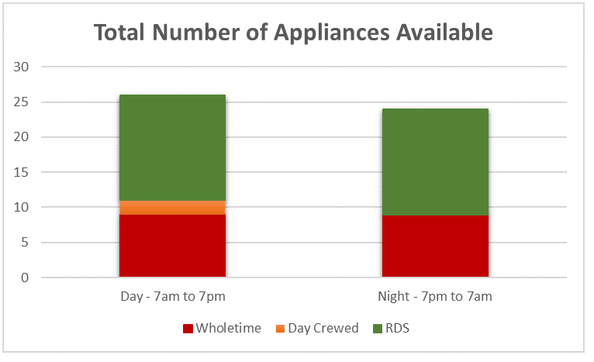

Degradation plan

Our degradation plan considers a range of local and national events. These include the reasonable planning assumption of responding to two simultaneous incidents of 5 pumps or one large incident of 10 pumps. The degradation plan also provides the strategic location of the number of required appliances for normal business. Management intervention is enacted when the Service reaches a heightened state of appliance availability, this is defined at below 15 appliances.

Response standards

Following our consultation in 2021 you asked us to carry out an extensive review of our response standards which included looking at all our response data and attendance times over a 5-year period.

We are committed to responding to life risk incidents as quickly as possible. The proactive work our teams undertake, such as delivering HFSVs to the most vulnerable, continues to reduce risk and the number of incidents we attend. However, we continue to see a high level of risk to life as a result of accidental fires within the home and accidents on our roads. Conversely, we see much lower levels of risk to life from fires in non-domestic buildings, recording just ten injuries that required hospital treatment over a 5-year reporting period this is partly as a result of our engagement with businesses but also due to our risk-based approach to auditing premises.

Therefore, to ensure we remain focused on providing a prompt response to life risk incidents we implemented the new challenging response standards from 1st April 2022, and we monitor our performance against these. Overall CDDFRS is the fastest responding predominantly rural FRS.

Our Response Standards are:

- Attend Dwelling Fires in 8 minutes on 70% of occasions
- Attend Non Domestic Fires in 9 minutes on 70% of occasions
- Attend Road Traffic Collisions in 10 minutes on 70% of occasions

Last year’s performance against the Response Standards are as follows:

In 2023/24 we attended
- Dwelling Fires in 8 minutes on 69.1% of occasions.
- Non Domestic Property Fires in 9 minutes on 67.9% of occasions.
- Road Traffic Collisions in 10 minutes on 69.8% of occasions.

Our Approach

Our approach is designed to:

Protect frontline services – so far as we are able, our focus remains to protect our immediate 999 response service, continuing our lifesaving community safety initiatives and working to safeguard our buildings.

Identify risks and plan accordingly – the people we serve expect us to provide our firefighters and fire stations in the places they are needed the most. Our focus remains on keeping our communities safe by utilising our limited resources effectively to balance risk and demand.

Delivering for our communities and planning for the future – we know we make a difference across County Durham and Darlington, however with limited resources and significant uncertainty regarding our financial position over the forthcoming years we must plan for the future and consider all possible future funding scenarios.

Our 2024-2027 Consultation

In our 2024/27 consultation we outlined our plan for the year ahead and asked you to consider the following:

We asked | You said | We did
Do you agree with the Service's approach to keeping you safe? | Yes | In our last consultation we sought your views on our approach to keeping you safe. You agreed that our CRMP enables us to regularly review national, regional and local risks, ensuring our fire engines are prepared to respond when, and where they are most needed. We will continue to embed our CRMP into everything we do as your Fire and Rescue Service.
Do you agree with our commitments outlined in the plan?​ | Yes | During our last consultation, we presented a series of commitments to you which were outlined in our CRMP. You agreed with our plan to implement these commitments, and we remain dedicated to integrating the CRMP into everything we do.
Do you have any comments on our plans for 2024-27? | Yes | We received 799 responses to our 2024-2027 public consultation, with more than 240 individuals providing detailed feedback on our plans. As a Service, we highly value all feedback, and we thoroughly reviewed and considered every piece of feedback we received.

We said, we did…

In our 2024/27 CRMP consultation we told you about what we would do in the following year. Here’s what we did:

We said:
Monitor the crewing of Wholetime fire engines.

We did:
In July 2023, the Service implemented the crewing of the wholetime fire appliances at five fire stations the crewing of wholetime fire engines, with four firefighters.

Throughout 2023 and 2024, we monitored the operational activity and operational performance of each of the five fire stations. We found no operational performance or health and safety issues reported that were directly attributable to the implementation of this action.​

We have also conducted a review of our response times 12 months prior to implementation, and 12 months following implementation, the results of which highlights that the Service’s response times were maintained.​ We will continue to monitor this activity in the coming year through our normal assurance processes.

We said:
Implement the findings following the review of the Risk Based Inspection Programme.

We did:
The review produced an updated Risk Based Inspection Programme (RBIP) with an increased focus on premises types that have been identified through national research as a higher risk. These premise types include care homes, hotels, hospitals and residential buildings over four storeys tall.
The new RBIP implemented by our Service on 31 March 2024, has increased the number of premises in our Service area classed as higher risk from 40 to 734. Many of these premises now classed as higher risk have not been inspected for several years. We have developed a three-year plan to ensure all these premises receive an inspection. Once inspected all higher risk premises will receive a reinspection at least, every three years thereafter.

We said:
Continue to monitor the staffing arrangements and application of Targeted Response Vehicle’s (TRV’s).

We did:
The TRV and its staff operate independently at low impact low risk incidents. In doing so they increase the availability of front line fire engines. This is especially effective between 4pm and 9pm. They also support the wider operational capability either through provision of equipment and/or personnel at high impact incidents.​
Other supporting roles include enhancing operational cover at on call stations, standby cover at wholetime stations as well as forming part of our Business Continuity arrangements.​ The TRV is comfortable in dealing with varying terrains and is used for assisting in flood conditions, at wildfires and during other such spate conditions or complex incidents.​
More recently the TRV and staff have been utilised alongside partners for anti-social behaviour collaboration initiatives aiming to reduce unwanted deliberate and nuisance fire setting in hot spot areas.​

We said:
Continue to explore opportunities and evaluate changes introduced through collaboration projects.

We did:
Over the past year our Service has been involved in several collaboration projects.
We are working in collaboration with three other FRSs Cleveland, Hereford & Worcester and Shropshire to integrate a new Fire Command and Control system that will save us approx. £1.9m over the 7-year contract. The joint system increases resilience and fallback arrangements including the handling of each other's calls during spate conditions or day to day business disruption.
Other benefits include the reduction of carbon footprint through sharing of telephone lines, freeing up of technology infrastructure by moving to a cloud-based approach as well as improved cyber security.
We have reviewed the Community Safety Responders roles in Weardale, signing a new agreement with Durham Constabulary. They now focus on a dual role of Community Support Officer and On Call Firefighter, with performance indicators reported through the Collaboration Board. ​
We have signed an agreement with Tyne and Wear Fire and Rescue Authority (TWFRA) whereby experts in Data Protection from TWFRA assist County Durham and Darlington Fire and Rescue Authority with meeting its responsibilities to the Information Commissioners Office and its legal duties arising from the Data Protection Act 2018.​
We continue to collaborate on our Service Estate with partners from Durham Constabulary and North East Ambulance Service and are pursuing further collaboration on other schemes.​

Our Options

We have already described our challenges, our approach to addressing them and the context behind County Durham and Darlington and our Service.

In preparing this plan, we have carried out a thorough and sophisticated analysis of the available data and financial information.

Over the duration of the last CRMP We have:

- Reduced our expenditure on areas other than staff pay through a comprehensive review of departmental spend.
- Saved money by buying equipment or sharing resources in collaboration with other FRS, these include sharing specialist vehicles and specialist posts.

If our performance is to continue to improve, it is therefore even more important that we:

- Continue to innovate to remove bureaucracy, improve efficiency and find new ways of working to free up capacity;
- Explore all opportunities for collaboration that improve value for money, improve outcomes, reduce risk for our communities and reduce demand on our service;
- Ensure our resources are allocated in the most appropriate way to maximise the impact we can have on the risks that our communities face.

We know that our staff are our greatest asset, and we need to ensure they have the right skills and are available in the right places at the right time to carry out their roles effectively.

Our Commitments

We want to provide you with the best possible Service we can with the resources that we have.

To make sure we do this we have made a series of commitments throughout this plan. Here they are together:

Be the Best
Recruit and retain a diverse workforce and continually assess their performance and behaviours.

Prevent
Target at least 80% of our HFSVs to the most vulnerable people, taking referrals from and making them to our supporting partners.
Protect
Work with local businesses to keep people safe from fire and take enforcement action when we need to.

Respond
In an emergency we will be fully prepared to respond and will strive to reduce the impact.

Improve
We will constantly endeavour to improve by monitoring our performance and encourage our staff to be innovative.

Learn
We will learn and improve following scrutiny from HMICFRS, the CFA, external audit bodies and our consultation process

Plan
We will identify the risks you face and plan ways to reduce their impact using our staff and resources effectively.
Budget
We will use our budget, people and equipment effectively to tackle our risks and keep you safe.

Consultation

We are constantly striving to make our prevention, protection and response services to you better and we are accountable to you in everything we do. We want to hear from you about how we can improve and shape our activities over the next three years. As we develop our plans, we will consult with you on any specific proposals so that we can fully understand the impact they may have.

The more informed we are by your views, the more able we are to meet your aspirations and deliver positive outcomes for the residents of County Durham and Darlington.

Do you agree with this consultation approach?

During our annual consultation exercise, we aim to consult with a representative sample of the community we serve. This means consulting with as many of the population across County Durham and Darlington as possible. Our aim is to receive as many responses as we can to ensure the sample size is robust, which means we can be confident in the findings of the consultation.

This year we will be consulting both online and out in the community, for example at your local Area Action Partnership meeting. If you have any difficulties with internet access let us know by telephone and we can provide you with a paper copy of our survey.

Our 2025-2028 Consultation

This year we want to hear your views on the following questions:
Question 1:
We will invest further with partner agencies to increase our access to people vulnerable from fire and other emergencies. Do you agree?
Question 2:

We aim to reduce the impact that deliberate fires have on our communities through targeted interventions and prevention activity. Do you agree?

Question 3:

To ensure we provide the best service to the public we will invest in our people by promoting our approach to recruitment, retention and staff well-being. Do you agree?

Question 4:

We are committed to continually improving our on-call response model. Do you agree?

Question 5:

To meet the challenges of the future and reduce our impact on the environment we will invest in our buildings, equipment and technology. Do you agree?

Complete the online survey here

Our Plans

In 2025/26 the following options will be considered

- Review the newly implemented Service Risk-Based Inspection Programme
- Continue to explore opportunities and evaluate changes introduced through collaboration projects.

In 2026/27 the following options will be considered

- Implement any changes to the Service Risk-Based Inspection Programme identified by the review in 2025/26
- Continue to explore opportunities and evaluate changes introduced through collaboration projects.

In 2027/28 the following options will be considered

- Continue to explore opportunities and evaluate changes introduced through collaboration projects

How do we consult?

This year’s consultation runs from 19 February 2025 to 14 May 2025. We will be carrying out a brief survey to capture your views and you can also email governance@ddfire.gov.uk with your comments.

This year’s survey asks you to answer some key questions and is available to complete:

- On our website;
- On our Facebook page;
- During a Home Fire Safety Visit;
- At online events and meetings;
- At in person events and meetings.

We will be consulting over a period of 12 weeks, with the next set of results available in June 2025. To read about all our plans and to complete our survey please visit our website.

If you would like to request a paper copy of the survey, a translation into another language, or need any assistance, please call us on 0345 305 8383.

