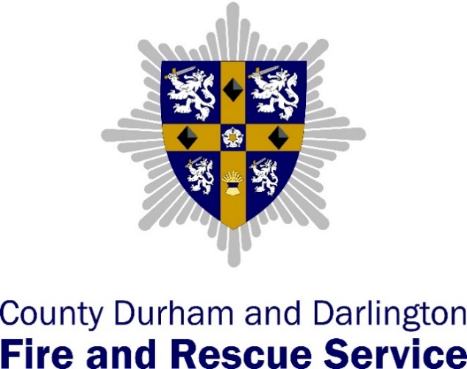

Bishop Auckland
Station Plan 2021 – 2022
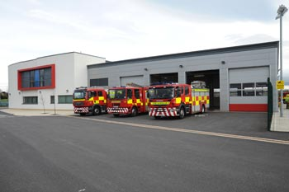

Bishop Auckland Watch Managers
- WM Lee Thomas
- WM Andrew Singlewood
- WM Dave Welsh
- WM Sam Rye
- WM Jonner Robinson
- WM Karl Blackburn

Introduction
Welcome to our Bishop Auckland station plan for 2021/22. This plan covers the Bishop Auckland Fire Station area and establishes our approach to the mitigating actions that will reduce the risks prevalent in the Darlington area and described within the Service Community Risk Profile. Reduction of these risks will support the Service vision of the Safest People, Safest Places.
The risks identified within this station plan are informed by the National Risk Register, the Local Resilience Forum Community Risk Register and an assessment of our local risks using data from our partners, business intelligence and operational incident information.
Risks from the Service Community Risk Profile that are applicable to the Bishop Auckland station area are shown in the risk rating matrix below:
Impact of the reasonable worst case scenario | 5
Impact of the reasonable worst case scenario | 4 | R19 Buildings of heritage and special interest | R17 Waste and recycling sites |  |  | R1 Dwelling fires  R4 Road vehicle fires  R6 Secondary fires
Impact of the reasonable worst case scenario | 3 |  |  | R2 Other residential building fires  R8 Rescues from water  R14 Flooding  R15 Industrial fires | R5 Other outdoor fires  R16 Incidents involving hazardous materials | R3 Other non-residential building fires  R10 Road Traffic Collisions (RTCs)
Impact of the reasonable worst case scenario | 2 |  |  | R9 Rescues from height
Impact of the reasonable worst case scenario | 1 |  |  |  | R18 Animal incidents
Risk rating matrix |  | 1 | 2 | 3 | 4 | 5
 |  | Likelihood of reasonable worst case scenario of risk occurring in the next year
Mitigating actions: In order to reduce the risks throughout our communities, the following mitigating actions apply to the risks identified within the Darlington station area:

R1 Dwelling fires
- Raise awareness, and campaign to prevent fires and promote community safety.
- Use the service business information and intelligence systems (PowerBi, Cadcorp and Slicer) to identify individuals and properties with the most significant vulnerabilities or who are a higher risk.
- Deliver specific safe and wellbeing advice to meet the needs of individuals and make referrals to partner organisations where vulnerabilities are identified.
- Identify and report safeguarding concerns when necessary
- Maintain operational competence to be able to respond safe and effectively to dwelling fires

R2 Other residential and non-residential building fires
- Use the business risk identification process to identify and prioritise residential and non-residential buildings at risk
- Deliver consistent and robust fire safety audits, and take enforcement action against those who fail to comply with fire safety regulations
- Maintain operational risk information relevant to residential and non-residential buildings to provide operational crews with an awareness of hazards and risks should an incident occur.
- Undertake periodic familiarisation visits to the higher risk buildings
- Develop and maintain incident plans for high risk buildings
- Conduct training exercises with occupiers to test the suitability of plans

R3 Other non-residential building fires
- Use the business risk identification process to identify and prioritise residential and non-residential buildings at risk
- Deliver consistent and robust fire safety audits, and take enforcement action against those who fail to comply with fire safety regulations
- Maintain operational risk information relevant to residential and non-residential buildings to provide operational crews with an awareness of hazards and risks should an incident occur.
- Undertake periodic familiarisation visits to the higher risk buildings
- Develop and maintain incident plans for high risk buildings
- Conduct training exercises with occupiers to test the suitability of plans.

R4 Road vehicle fires
- Conduct fire investigations into road vehicle fires to determine the prevalence of arson.
- Scrutinise road vehicle fire data to identify trends and report to divisional managers and partners.

R5 Other outdoor fires
- Maintain operational competence to be able to respond safe and effectively to other outdoor fires

R6 Secondary fires
- Deliver prevention work with partners to reduce the opportunity and consequences of secondary fires.
- Analyse incident data to identify areas of concern and deliver interventions to reduce the prevalence of secondary fires
- Maintain operational competence to be able to respond safe and effectively to secondary fires

R8 Rescues from Water
- Maintain risk information relevant to locations where water related incidents and rescues have occurred within the station area
- Undertake periodic familiarisation visits to the locations where water related incidents and rescues have occurred within the station area
- Maintain operational competence to be able to respond safe and effectively to rescues form water
- Visit locations where people gather near water to deliver water safety advice

R9 Rescues from Height
- Maintain risk information relevant to locations where height related incidents and rescues have occurred within the station area
- Undertake periodic familiarisation visits to the locations where height related incidents and rescues have occurred within the station area
- Maintain operational competence to be able to respond safe and effectively to rescues from height

R10 Road Traffic Collisions
- Work with partners and support national and local campaigns to deliver targeted activities with the aim of reducing the number of RTCs
- On a periodic basis, deliver a training exercise to test the emergency response to a significant road traffic collision requiring a number of casualty extrications
- Maintain operational competence to enable a safe and effective response to this risk

R14 Flooding Incidents
- Maintain an awareness of the local resilience forum flood plans relevant to the locations of the station area where flooding is likely to occur.
- Maintain operational competence (aligned to the DEFRA Flood Response Concept of Operations) to enable a safe and effective response to this risk

R15 Industrial Incidents
- Use the business risk identification process to identify and prioritise residential and non-residential buildings at risk
- Deliver consistent and robust fire safety audits, and take enforcement action against those who fail to comply with fire safety regulations
- Maintain risk information relevant to industrial premises within the station area
- Undertake periodic familiarisation visits to the higher risk industrial sites
- For premises where the risk is at a high level, develop and maintain operational incident plans in partnership with owner/occupiers to ensure a safe and effective response to incidents at industrial premises
- Maintain operational competence to enable a safe and effective response to this risk

R16 Hazardous Materials Incidents
- Maintain risk information relevant to buildings where hazardous materials are stored, used or manufactured within the station area
- Conduct training exercises with occupiers to test the suitability of plans
- Undertake periodic familiarisation visits to the higher risk buildings
- For premises where the risk is at a high level, develop and maintain operational incident plans in partnership with owner/occupiers to ensure a safe and effective response to hazardous materials incidents

R17 Waste Disposal Site Fires
- Maintain risk information relevant to waste disposal sites
- Analyse incident data to identify trends and locations where interventions are needed, and work in partnership with the Local Authority and Environment Agency to reduce the risk from fires in waste disposal sites.
- Maintain operational competence to enable a safe and effective response to this risk

R18 Animal Incidents
- Maintain an awareness of the ART capabilities and request their assistance (and other organisations such as the RSPCA or local vets) to deal with animal incidents in required.
- Maintain operational competence to enable a safe and effective response to an animal related scenario.

R19 Buildings of Heritage and Special Interest
- Maintain risk information relevant to heritage buildings within the station area
- Undertake periodic familiarisation visits to the higher risk buildings
- For buildings of heritage and special interest where the risk is at a high level, develop and maintain operational incident plans in partnership with owner/occupiers to ensure a safe and effective response (including salvage).
- Conduct training exercises with occupiers to test the suitability of plans
- Maintain operational competence to enable a safe and effective response to fires in buildings of heritage and special interest

Performance targets

Safe and Wellbeing visits
Station | Apr | May | Jun | Jul | Aug | Sep | Oct | Nov | Dec | Jan | Feb | Mar | Total
Bishop Auckland (12) | 133 | 148 | 141 | 159 | 154 | 151 | 138 | 150 | 121 | 138 | 111 | 36 | 1580

Business fire safety audits
- Bishop Auckland monthly target 24
- Annual target 276

Watch Ward Areas
- The ward areas within the Bishop Auckland station area are allocated to the four watches, as shown below:

Red Watch | White Watch | Blue Watch | Green Watch | RDS
 | Dene Valley | Cockfield | Cockton Hill | B/A Town centre
 | Coundon | Etherley | Woodhouse Close
 |  | Evenwood | Henknowle
 |  | West Auckland

Bishop Auckland Station High Risk Visit Programme 2021 - 2023
- Annual visits by all watches:

High Risk Premises | Red Watch | White Watch | Blue Watch | Green Watch | RDS
 |  |  | Hamsterley Forest | BA Hospital
 |  |  | Vinovium House | Raby Castle
 |  |  | Shildon Tunnel | Kynren
 |  |  |  | PPG from 2020

Prevention

Safe and Wellbeing visits
School visits | St Annes primary  Woodhouse close primary  Cockton Hill  St Wilfreds primary  St Andrews primary  Etherley Lane primary  Escomb primary | St Helens Auckland Primary  Copeland Rd Primary  Oakley Cross Primary  Toft Hill Primary  Ingleton Primary  Cockfield Primary  Evenwood CE Primary | Victoria Lane Academy  Embleton View SEN School  Prince Bishops Primary School  St Joseph's Primary  St Andrews Primary

Protection

Business fire safety audits
ORI/incident plans

Efficiency

Hydrants |  |  | N06,N34

People

Appraisals |  | Complete Mid year review Sep. | Current and up to date
Personal accidents
Vehicle accidents |  |  | 1 Reported
Near misses reported
Cause for concerns reported |  |  | 2 Reported
% sickness
Completion of appraisals |  | 100%

Outcomes

Accidental dwelling fires
Primary fires
Secondary fires
Deliberate primary fires
Deliberate secondary fires

Training/Tactical exercises

Tactical exercises | Broken Scar with NYFRS water rescue |  | USAR Exercise TWFRS

Operational readiness audit (OPERA) action plans

Summary update on the number of outstanding OpeRA actions and progress of the existing action plans

RDS
Red Watch
Green Watch | - ETHANE MSG review  - SMART objectives in appraisals
White Watch | - Improved use of Station diary – Ongoing and now utilised more.  - SWBV lifestyle questions bellow service average – Continuously monitored and importance impressed to crews.  - Complete joint training with neighbouring FRS with station specialisms – Looking to complete in Autumn when more appropriate weather conditions for SWRT with North Yorkshire  - More thorough use of driving records – Now utilised daily and monitored.  - Improved Arson reduction strategies – Lifting of COVID restrictions now prioritising strategies in line with Operational commitments.
Blue Watch

Delivery and monitoring of the station action plan

Delivery of the mitigating actions to reduce risk in the Darlington station area and other areas of station performance will be evaluated through the monitoring of Service performance and management indicators, which in turn will influence future iterations of the Service Community Risk Profile and the corresponding Community Risk Management Plan, and Service strategies, as shown below:

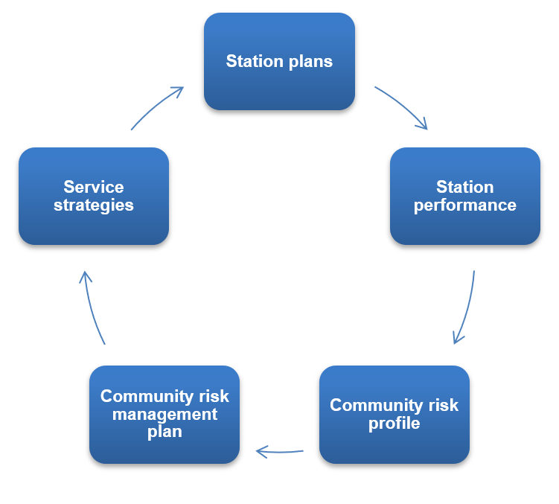

The station action plan is intended to be a ‘living document’ with updates added each month by watch mangers to show progress against the key areas of performance. Delivery of the station action plan will be monitored by divisional managers on a monthly basis during watch performance reviews.

