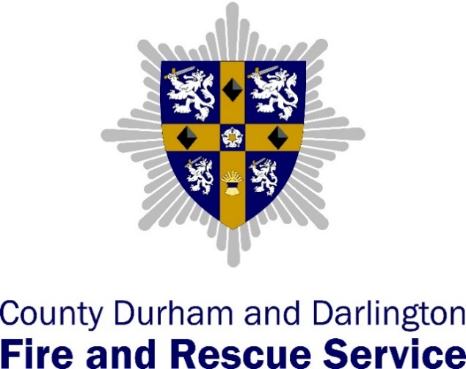

Spennymoor
Station Plan 2021 – 2022
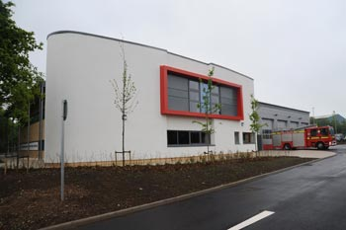

Spennymoor Watch Managers
- WM Dave Tempest
- WM Kieran Thompson
- WM Anthony Hardy
- WM Dave Welsh
- WM Steve Smith
Introduction
Welcome to our Spennymoor station plan for 2021/22. This plan covers the Spennymoor Fire Station area and establishes our approach to the mitigating actions that will reduce the risks prevalent in the Spennymoor area and described within the Service Community Risk Profile. Reduction of these risks will support the Service vision of the Safest People, Safest Places.
The risks identified within this station plan are informed by the National Risk Register, the Local Resilience Forum Community Risk Register and an assessment of our local risks using data from our partners, business intelligence and operational incident information.
Risks from the Service Community Risk Profile that are applicable to the Spennymoor station area are shown in the risk rating matrix below:
Impact of the reasonable worst case scenario | 5
Impact of the reasonable worst case scenario | 4 | R19 Buildings of heritage and special interest | R17 Waste and recycling sites |  |  | R1 Dwelling fires  R4 Road vehicle fires  R6 Secondary fires
Impact of the reasonable worst case scenario | 3 |  |  | R2 Other residential building fires  R8 Rescues from water  R14 Flooding  R15 Industrial fires | R5 Other outdoor fires  R16 Incidents involving hazardous materials | R3 Other non-residential building fires  R10 Road Traffic Collisions (RTCs)
Impact of the reasonable worst case scenario | 2
Impact of the reasonable worst case scenario | 1 |  | R11 Rail incidents |  | R18 Animal incidents
Risk rating matrix |  | 1 | 2 | 3 | 4 | 5
 |  | Likelihood of reasonable worst-case scenario of risk occurring in the next year
Mitigating actions: In order to reduce the risks throughout our communities, the following mitigating actions apply to the risks identified within the Spennymoor station area:

R1 Dwelling fires
- Raise awareness, and campaign to prevent fires and promote community safety.
- Use the service business information and intelligence systems (PowerBi, Cadcorp and Slicer) to identify individuals and properties with the most significant vulnerabilities or who are a higher risk.
- Deliver specific safe and wellbeing advice to meet the needs of individuals and make referrals to partner organisations where vulnerabilities are identified.
- Identify and report safeguarding concerns when necessary
- Maintain operational competence to be able to respond safe and effectively to dwelling fires

R2 Other residential and non-residential building fires
- Use the business risk identification process to identify and prioritise residential and non-residential buildings at risk
- Deliver consistent and robust fire safety audits, and take enforcement action against those who fail to comply with fire safety regulations
- Maintain operational risk information relevant to residential and non-residential buildings to provide operational crews with an awareness of hazards and risks should an incident occur.
- Undertake periodic familiarisation visits to the higher risk buildings
- Develop and maintain incident plans for high risk buildings
- Conduct training exercises with occupiers to test the suitability of plans

R3 Other non-residential building fires
- Use the business risk identification process to identify and prioritise residential and non-residential buildings at risk
- Deliver consistent and robust fire safety audits, and take enforcement action against those who fail to comply with fire safety regulations
- Maintain operational risk information relevant to residential and non-residential buildings to provide operational crews with an awareness of hazards and risks should an incident occur.
- Undertake periodic familiarisation visits to the higher risk buildings
- Develop and maintain incident plans for high-risk buildings
- Conduct training exercises with occupiers to test the suitability of plans.

R4 Road vehicle fires
- Conduct fire investigations into road vehicle fires to determine the prevalence of arson.
- Scrutinise road vehicle fire data to identify trends and report to divisional managers and partners.

R5 Other outdoor fires
- Maintain operational competence to be able to respond safe and effectively to other outdoor fires

R6 Secondary fires
- Deliver prevention work with partners to reduce the opportunity and consequences of secondary fires.
- Analyse incident data to identify areas of concern and deliver interventions to reduce the prevalence of secondary fires
- Maintain operational competence to be able to respond safe and effectively to secondary fires

R8 Rescues from Water
- Maintain risk information relevant to locations where water related incidents and rescues have occurred within the station area
- Undertake periodic familiarisation visits to the locations where water related incidents and rescues have occurred within the station area
- Maintain operational competence to be able to respond safe and effectively to rescues form water

R10 Road Traffic Collisions
- Work with partners and support national and local campaigns to deliver targeted activities with the aim of reducing the number of RTCs
- On a periodic basis, deliver a training exercise to test the emergency response to a significant road traffic collision requiring a number of casualty extrications
- Maintain operational competence to enable a safe and effective response to this risk

R11 Rail Incidents
- Maintain operational risk information relevant to railways stations to support the consistency of approach in dealing with this incident type.
- Maintain operational competence to enable a safe and effective response to this risk

R14 Flooding Incidents
- Maintain an awareness of the local resilience forum flood plans relevant to the locations of the station area where flooding is likely to occur.
- Maintain operational competence (aligned to the DEFRA Flood Response Concept of Operations) to enable a safe and effective response to this risk

R15 Industrial Incidents
- Use the business risk identification process to identify and prioritise residential and non-residential buildings at risk
- Deliver consistent and robust fire safety audits, and take enforcement action against those who fail to comply with fire safety regulations
- Maintain risk information relevant to industrial premises within the station area
- Undertake periodic familiarisation visits to the higher risk industrial sites
- For premises where the risk is at a high level, develop and maintain operational incident plans in partnership with owner/occupiers to ensure a safe and effective response to incidents at industrial premises
- Maintain operational competence to enable a safe and effective response to this risk

R16 Hazardous Materials Incidents
- Maintain risk information relevant to buildings where hazardous materials are stored, used or manufactured within the station area
- Conduct training exercises with occupiers to test the suitability of plans
- Undertake periodic familiarisation visits to the higher risk buildings
- For premises where the risk is at a high level, develop and maintain operational incident plans in partnership with owner/occupiers to ensure a safe and effective response to hazardous materials incidents

R17 Waste Disposal Site Fires
- Maintain risk information relevant to waste disposal sites
- Analyse incident data to identify trends and locations where interventions are needed, and work in partnership with the Local Authority and Environment Agency to reduce the risk from fires in waste disposal sites.
- Maintain operational competence to enable a safe and effective response to this risk

R18 Animal Incidents
- Maintain an awareness of the ART capabilities and request their assistance (and other organisations such as the RSPCA or local vets) to deal with animal incidents in required.
- Maintain operational competence to enable a safe and effective response to an animal related scenario.

R19 Buildings of Heritage and Special Interest
- Maintain risk information relevant to heritage buildings within the station area
- Undertake periodic familiarisation visits to the higher risk buildings
- For buildings of heritage and special interest where the risk is at a high level, develop and maintain operational incident plans in partnership with owner/occupiers to ensure a safe and effective response (including salvage).
- Conduct training exercises with occupiers to test the suitability of plans
- Maintain operational competence to enable a safe and effective response to fires in buildings of heritage and special interest

Performance targets

Safe and Wellbeing visits
 | Apr | May | Jun | Jul | Aug | Sept | Oct | Nov | Dec | Jan | Feb | Mar | Total
RDS | 15 | 15 | 15 | 15 | 15 | 15 | 15 | 15 | 15 | 15 | 15 | 15 | 180
Blue | 30 | 30 | 30 | 30 | 30 | 30 | 30 | 30 | 30 | 30 | 30 | 30 | 360
Green | 30 | 30 | 30 | 30 | 30 | 30 | 30 | 30 | 30 | 30 | 30 | 30 | 360
Red | 30 | 30 | 30 | 30 | 30 | 30 | 30 | 30 | 30 | 30 | 30 | 30 | 360
White | 30 | 30 | 30 | 30 | 30 | 30 | 30 | 30 | 30 | 30 | 30 | 30 | 360
Total | 135 | 135 | 135 | 135 | 135 | 135 | 135 | 135 | 135 | 135 | 135 | 135 | 1620

Business fire safety audits
 | Apr | May | Jun | Jul | Aug | Sept | Oct | Nov | Dec | Jan | Feb | Mar | Total
Blue | 3 | 3 | 3 | 3 | 3 | 3 | 3 | 3 | 3 | 3 | 3 | 3 | 36
Green | 3 | 3 | 3 | 3 | 3 | 3 | 3 | 3 | 3 | 3 | 3 | 3 | 36
Red | 3 | 3 | 3 | 3 | 3 | 3 | 3 | 3 | 3 | 3 | 3 | 3 | 36
White | 3 | 3 | 3 | 3 | 3 | 3 | 3 | 3 | 3 | 3 | 3 | 3 | 36
Total | 12 | 12 | 12 | 12 | 12 | 12 | 12 | 12 | 12 | 12 | 12 | 12 | 144

Watch Ward Areas
- The ward areas within the Spennymoor station area are allocated to the four watches and RDS, as shown below:

Red Watch | White Watch | Blue Watch | Green Watch | RDS
Low Spennymoor & Tudhoe Grange | Ferryhill | Bishop Middleham & Cornforth | Cassop-Cum-Quarrington | Tudhoe
Coxhoe | Broom | Middlestone | Spennymoor

Spennymoor Station High Risk Visit Programme 2021 - 2023
- Annual visits by all watches:

High Risk Premises | Red Watch | White Watch | Blue Watch | Green Watch | RDS
Tarmac Aggregates
Amazon |  |  | 10/02/2021 and 23/04/2021
High Force Research |  |  | 18/02/2021
Spennymoor Electrical Substation (North and South) |  |  | 25/05/2021
Veolia Bio Energy (Stn 11)
Inovyn (Stn 11)
Mitsubishi Chemicals (Stn 11)
Prefere Resins (Stn 11)
IIV-I Semiconductors (Stn 11)
Durham Cathedral (Stn 06)
University Science Suite (Stn 06)
HMP Durham (Stn 06)
Netpark, Sedgefield (Stn 10)
Bishop Auckland Castle (Stn 12)

Prevention

Safe and Wellbeing visits
School visits

Protection

Business fire safety audits
ORI/incident plans

Efficiency

Hydrants

People

Appraisals
Personal accidents
Vehicle accidents
Near misses reported
Cause for concerns reported
% sickness
Completion of appraisals

Outcomes

Accidental dwelling fires
Primary fires
Secondary fires
Deliberate primary fires
Deliberate secondary fires

Training/Tactical exercises

Tactical exercises | Red Watch | White Watch | Blue Watch | Green Watch | RDS
Heritage building fire at Whitworth Hall or similar. | ✓ |  |  |  | ✓
Multi Vehicle RTC on the A1(M) |  | ✓ |  |  | ✓
Work at Height/confined space rescue. |  |  | ✓ |  | ✓
Haz Mat leak/spill inc. rescue and contamination using HMEPU. |  |  |  | ✓ | ✓

Operational readiness audit (OPERA) action plans

Summary update on the number of outstanding OpeRA actions and progress of the existing action plans

Red Watch
White Watch
Blue Watch
Green Watch
RDS

Delivery and monitoring of the station action plan

Delivery of the mitigating actions to reduce risk in the Spennymoor station area and other areas of station performance will be evaluated through the monitoring of Service performance and management indicators, which in turn will influence future iterations of the Service Community Risk Profile and the corresponding Community Risk Management Plan, and Service strategies, as shown below:

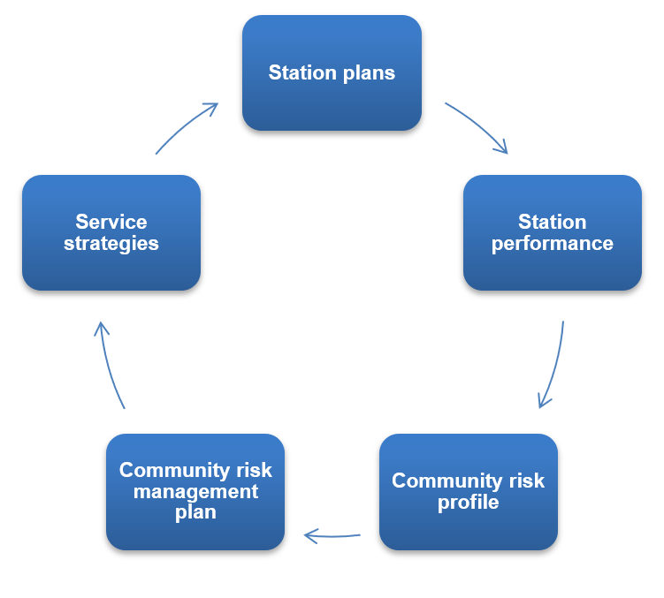

The station action plan is intended to be a ‘living document’ with updates added each month by watch mangers to show progress against the key areas of performance. Delivery of the station action plan will be monitored by divisional managers on a monthly basis during watch performance reviews.

